Easy to read

How to get and use data to make life better for people with disabilities

Data is another word for information

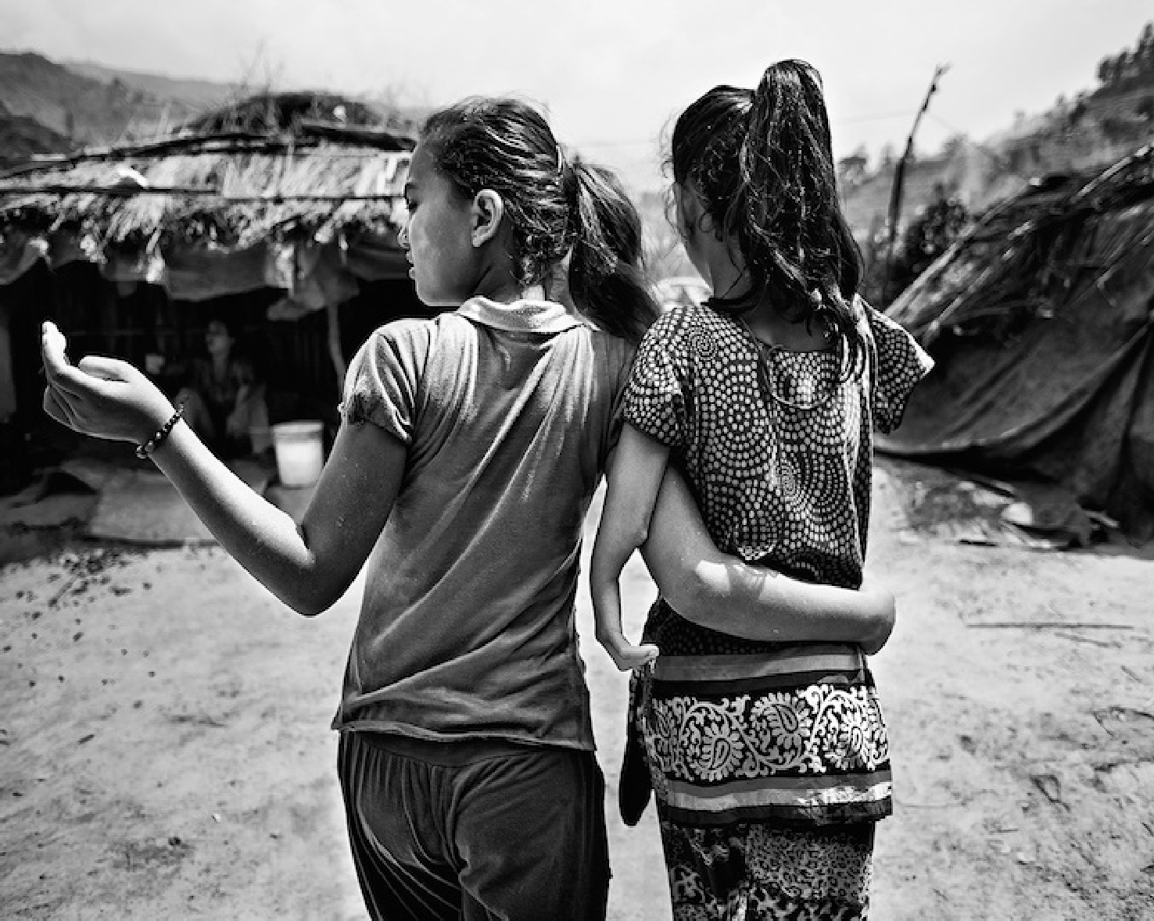
Disability Data Advocacy Toolkit
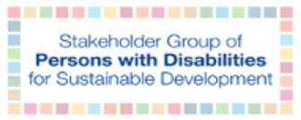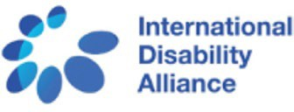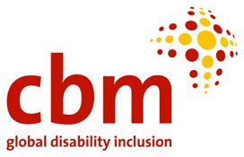

What is in this document

About this document 3

What is data and why is it important? 5

What countries should be doing 8

What people with disabilities and disability organisations can do 11

Things to think about when you use data 14

Some places to find data about people with disabilities 19

Projects to do with data 21

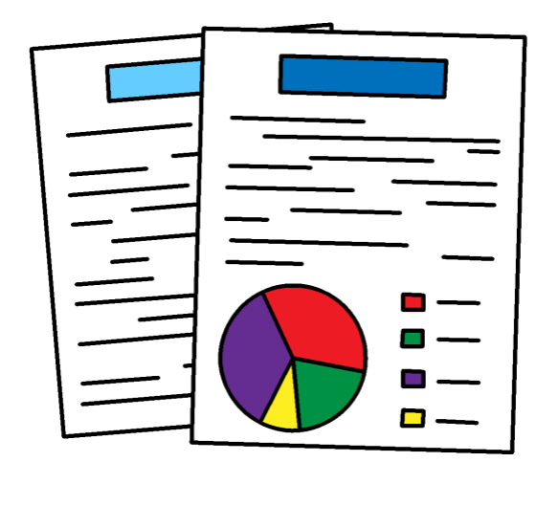

About this document

This document is about data about people with disabilities.

Data is another word for information.

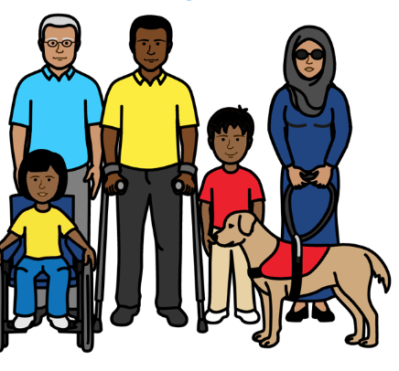

Data is very important.

It can be used to help make life better for people with disabilities.

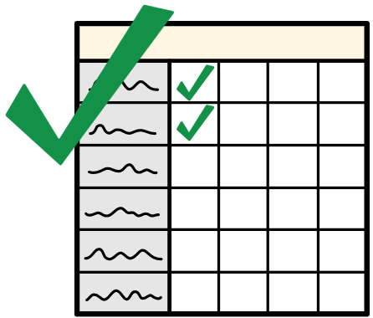

This document talks about:

- What data is and why it is important

- How you can help to get better data about people with disabilities

- How to use data and what to look out for

The CBM Disability Data Advocacy Toolkit covers the main points from a longer document about data. It is not in easy words.

What is data and why is it important?

Data can be numbers.

For example, the number of people with disabilities who go to school.

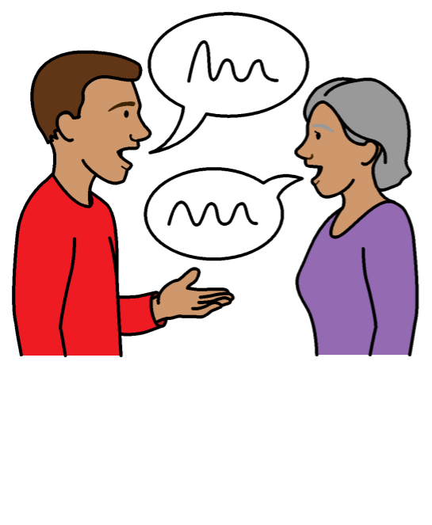
Data can also be information to show what people think and feel.

For example, stories about people’s lives.

Data can come from many places like:

- Information that governments keep about people in the country

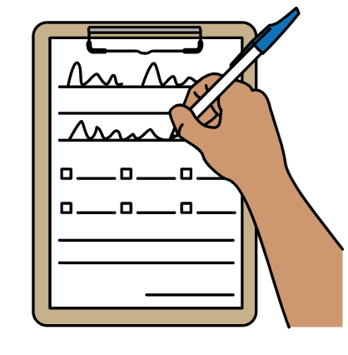
- Reports that organisations write

- Surveys and interviews where people answer questions about their lives

Why is data important?

People need data to understand what is working well and what needs to change.

For example, data might show that many people with disabilities are not in work.

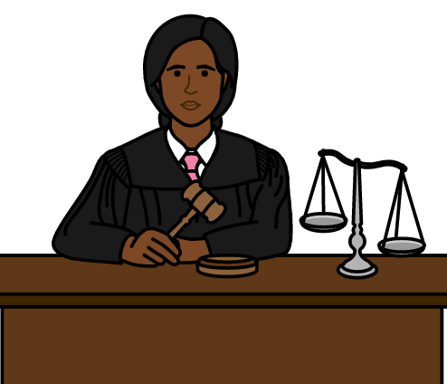

This can help governments and other people know what to change.

It can help them make good laws and plans to solve the problems.

Some good work is happening to get more data on people with disabilities.

But there is not enough data yet.

This means many problems for people with disabilities are not being solved.

What countries should be doing

Many countries have promised to get good data about people with disabilities.

This is part of important work that countries are doing.

For example, many countries have promised to follow a document about the rights of people with disabilities.

The document is called the UN Convention on the Rights of Persons with Disabilities.

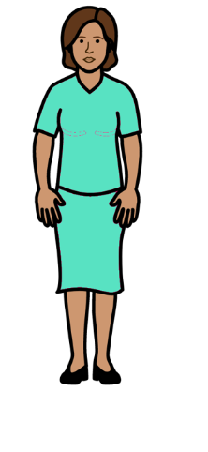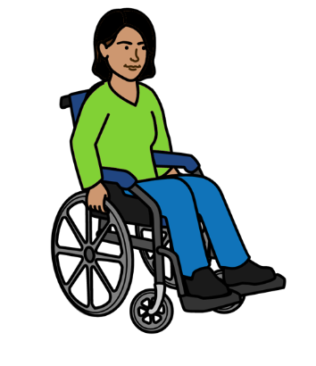

The document says that countries must get good data about people with disabilities and people without disabilities.

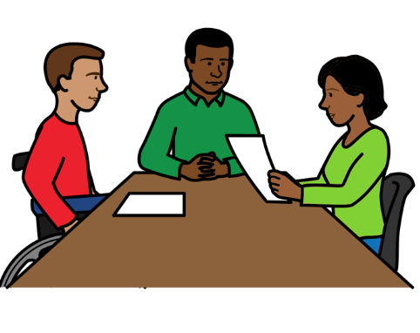
Countries should use the data to:

Understand what problems people with disabilities are having

Try to solve the problems to make life better for people with disabilities

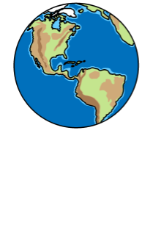

Countries are also working together to make the world better for everyone by the year 2030.

This work is called the Sustainable Development Goals.

Or SDGs for short.

Countries have agreed to get data about people with disabilities to help with that work.

For example, data about how many people with disabilities are in education, training and work.

What people with disabilities and disability organisations can do
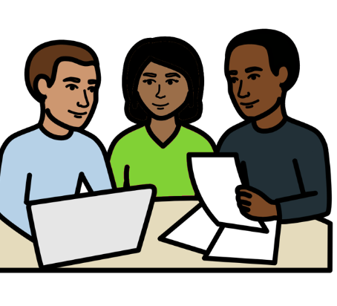

You can find out what data there is about people with disabilities.

There are some places that you might find data from on page 13 of this document.

You can check if your government is getting the data it agreed to about people with disabilities.

There is more information about what countries should be doing on page 6 of this document.

You can ask your government to get better data about people with disabilities if they are not getting enough.

You can help to get your own data if there is not enough.

For example, you could make a survey to ask people with disabilities questions.

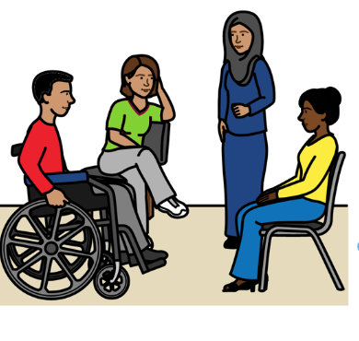

There are some questions you can use to find out about people with disabilities and their lives.

They are called the Washington Group Questions.

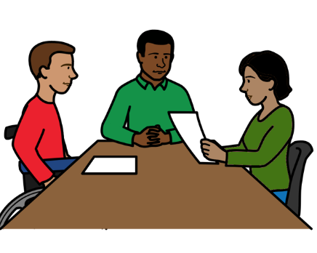
Then you can use the data you have to show governments and other people what needs to change for people with disabilities.

Things to think about when you use data
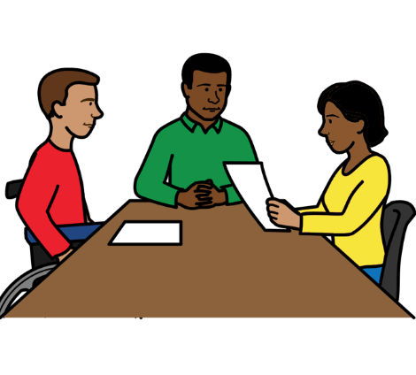
You need to look at the data you have and work out what it means.

There are some things to think about first.

For example:

Is the data right for what you need?

Is it about the right groups of people?

Does it show what you need it to?

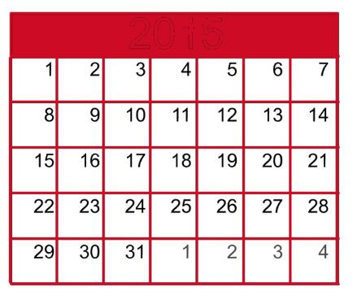

Who made the data and when?

Is the data still useful if it is old?

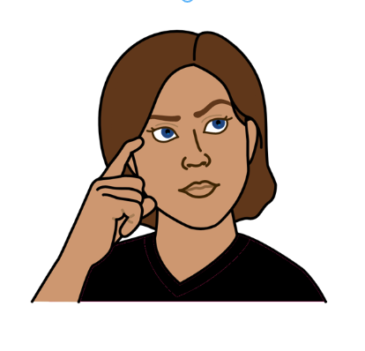

How was the data made?

Was it made in a good way that you can trust?

How many people is the data about?

Is it a large group of people or only a small group?

Does the data show what is happening to people with disabilities and people without disabilities?

For example, how many people with disabilities are poor.

And how many people without disabilities are poor.

Data like this is important. It can show how life is different for people with disabilities.

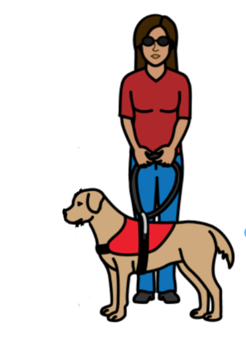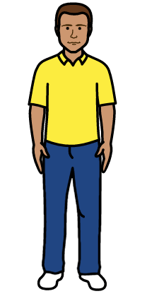

Can the data show even more information?

For example, how many women with disabilities are poor.

And how many men with disabilities are poor.

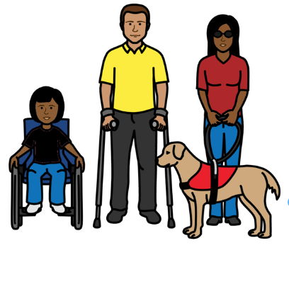
This shows if some people with disabilities are treated worse than others.

Does the data show what is happening in different parts of the country or world?

This can show if some places are doing better than others.

Does the data show what has happened in different years.

This is so you can see if things have changed over time.

Is there other data you can use if the data you have is not enough?

It is often good to use different data together.

Some places to find data about people with disabilities

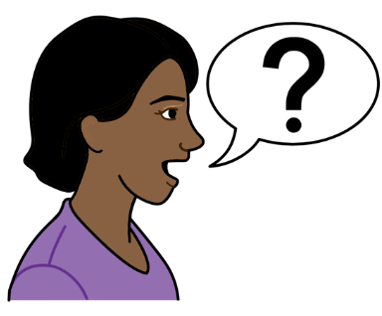

- The National Statistics Office for your country if there is one.

They keep data for the country.

They must give you any data they have about people with disabilities if you ask for it.
They must do this if your country has promised to follow the UN Convention on the Rights of Persons with Disabilities.

There is more information about this on page 6 of this document.

- The United Nations Statistics Division Disability Statistics Portal

- The Disability Data Portal

- SDG Data Hub

Projects to do with data

Disability Data Advocacy Working Group

They are helping to get more data about people with disabilities.

Making Voices Heard and Count

This is a new project about using data from local communities.

To find out more email:
pkoblowsky@icscentre.org

Pictures by The Picture Communication Symbols ©1981–2016 by Mayer-Johnson LLC a Tobii Dynavox company. All Rights Reserved Worldwide. Thousands of resources available for free at www.boardmakeronline.com
Document checked by Hackney People First. © European Easy-to-Read Logo: Inclusion Europe. More information at www.easy-to-read.eu.

