Key findings and recommendations on the impact of COVID-19 on persons with disabilities in Nigeria

Acknowledgements
This study was supported by the Stakeholder Groups of Persons with Disabilities. I would like to thank all persons with disabilities and family members who participated in the study and am grateful for the contributions of the research assistants and sign language interpreters. Many thanks to the Eastern Nigeria Association of the Deaf, for the extra step they took to mobilize Deaf leaders in the Zone and for the extraordinary support during the research visit to the region. I appreciate the support from the Vice Chancellor of the University of Calabar, Professor Florence Banku Obi who graciously granted me leave of absence for the duration of this study for me to devote full commitment to this important assignment from the Stakeholder Group of Persons with Disabilities. I would like to express special gratitude to Dr. Elizabeth Lockwood and Dr. Mary Keogh, whose technical support, mentorship, and guidance, steered the course of this research from start to finish. Also, to be recognized are Elodie Lacrampe and Debbie Gallagher, for the crucial services they provided throughout the research.

Table of Contents
Executive Summary 4
Context 6
Access to Social Protection a key issue 6
Challenges for OPDs during COVID-19 7
Picture: Discussing COVID-19 with Commission Directors in Nigeria 8
Methodology 8
Data Analysis and Synthesis of Findings 10
Daily Life 11
Safety 11
Emergency Plans 12
Conclusion 12
Recommendations 13
References 14

Executive Summary
This study explores the experiences of persons with disabilities in Nigeria during and after the COVID-19 lockdown. The research was undertaken during the period of February 1 to April 30, 2021. The objective of the study was to learn about the lived experiences of persons with disabilities in Nigeria during the COVID-19 pandemic and subsequent effects.

This research was a qualitative exploratory study which relied on interviews and documentation review to generate data. Information on the samples was gathered through in-depth, semi-structured, one-to-one interviews and life histories of 58 participants with disabilities from underrepresented groups across Nigeria. A population-based, cross-sectional survey of persons with disabilities was used to select respondents that belonged to underrepresented group of persons with disabilities. Additionally, snowball sampling was used to locate persons. Referrals were made by organisations of persons with disabilities, disability leaders, and services providers. Furthermore, seven research assistants identified target groups in remote communities in different regions.

The findings from the study show the following:

- The greatest barriers persons with disabilities encountered during the lockdown in Nigeria were access to social protection, lack of vital information about how to protect themselves and obtain PPE, as well as the COVID-19 vaccines disseminated in accessible formats.
- Most respondents (76%) stated that they cannot afford smartphones or internet services, and therefore cannot access websites.
- A higher number, 91%, stated that they do not have skills to use their phones for tasks other than making and receiving calls and sending text messages. They therefore could not go online to access COVID-19 information.
- Persons with disabilities who were interviewed did not think healthcare systems would value their lives equally to persons without disabilities and they would not be given life-saving procedures on equal basis with others.
- Additional findings shows that none of the respondents (100%) had received cash benefits related to COVID-19 from the government. Ten per cent of the respondents received food donations during the pandemic and 41% were aware of vaccines. However, no person interviewed (100%) had information on how to access the vaccine.

Based upon these findings, recommendations include the following:

- The Nigerian government and its agencies develop disability inclusive protocols for emergencies in line with its obligations under the CRPD.
- Information about COVID-19 should be made available in accessible formats for all persons with disabilities.
- To reach people without digital technology access, other public service announcements approaches should be explored, such as animated screensavers, radio announcements, and out-door digital projections and billboard adverts about COVID-19 safeguards.
- It is also recommended that inclusive education, being the catalyst for disability inclusion and social integration, should be used as a strategic tool to promote public awareness about disabilities.

Findings from this study could help improve disability-related policies, determine key advocacy efforts, and advance action-oriented plans toward achieving the Sustainable Development Goals.

Context
The COVID-19 pandemic overwhelmed the unprepared healthcare systems and plunged economies into depression. The devastations caused by the virus and its tenacity, has made it one of the most egregious pandemic in the history of humankind. Nigeria was one of the countries that suffered economic losses, but fewer human causalities from the pandemic. The National Centre for Disease Control (NCDC, 2021) reports that to date, Nigeria has approximately 152,000 cases of COVID-19 infections, with approximately 2000 COVID-19-related deaths. The first reported COVID-19 case in Nigeria was on February 27, 2020, in Lagos. In attempt to contain the spread of the virus, the Nigerian government, on March 30, 2020, imposed lockdowns in major cities throughout the country. This measure, while it was touted as a necessary safeguard to slow the spread of the virus, brought severe consequences to the unprepared citizens. The most marginalised citizens, among whom are persons with disabilities, were particularly affected and experienced increased and additional barriers, as well as further inequalities.

This study began with a courtesy visit to the Ministry of Humanitarian Affairs, Disaster Management and Social Developments in Nigeria’s capital city Abuja. This is the government agency which supervises organisations of persons with disabilities in Nigeria. Additionally, a visit was made to the Joint National Association of Persons with Disabilities (JONAPWD). The purpose was to understand the challenges of when persons with disabilities were looking for leadership in a time of crisis. A meeting was also held with the board members of the National Commission for Persons with Disabilities to learn about their agenda and plans, not only to better the lives of persons with disabilities in Nigeria, but also to ensure their inclusion in government programmes. The issues that emerged during these visits are detailed in the next sections.

Access to Social Protection
During the COVID-19 pandemic, millions of Nigerians including persons with disabilities, experienced acute economic deprivations arising from the stay-at-home order. In response, the government rolled out measures to compensate families for the economic losses the lockdown had caused them. Among the actions the Nigerian government took included the distribution of support to the country’s marginalised population, payment of a conditional cash transfer to impoverished households, and instituting the home grown school feeding programme that was provided to children who were at home due to the lockdown. Despite these laudable efforts, persons with disabilities were almost entirely excluded from those supports. Nigeria operates a “slot system” whereby politicians and the elites receive slots of relief materials for distribution to their constituents.

Recently, a State governor from the North lamented about Nigeria’s “slot mentality” and called for an end to it. According to the governor, Nigeria is a country with a significant number of poor people. Yet, whenever a programme is designed to help the poor and marginalised, the country resorts to a “slot mentality” in which important people are allocated slots instead of targeting those who are in most need. It is important to move away from the slot mentality and use the national social register to offer targeted support to those that truly need it. The national social register is a register of poor households in Nigeria compiled by the National Social Safety Net Coordinating Office (NASSCO). Only people whose names were included in the register were eligible for government’s social security support. Many persons with disabilities in Nigeria are not aware of or benefitting from social protection programmes.

Challenges for OPDs during COVID-19
As part of this research, organisations of persons with disabilities were consulted, including leadership from the Joint National Association of Persons with Disabilities (JONAPWD).
During the lockdown, people were forced to work from home. The JONAPWD national executive committee members could not afford data to hold virtual meetings. Consequently, JONAPWD did not have the necessary resources to easily strategise and support persons with disabilities during the crisis. Although some JONAPWD branches received supplies from their State governments, these supplies were limited and could not reach all members spread across the various States.
The newly inaugurated National Board of the National Commission for Persons with Disabilities also encountered barriers. The board directors and officers conducted business outside under a tree (refer to the photo below) since they did not have access to an office. Despite a well-defined agenda, without access to an indoor office and equipment, the commission faced obstacles to effectively carry out work.

Picture: Discussing COVID-19 with Commission Directors in Nigeria
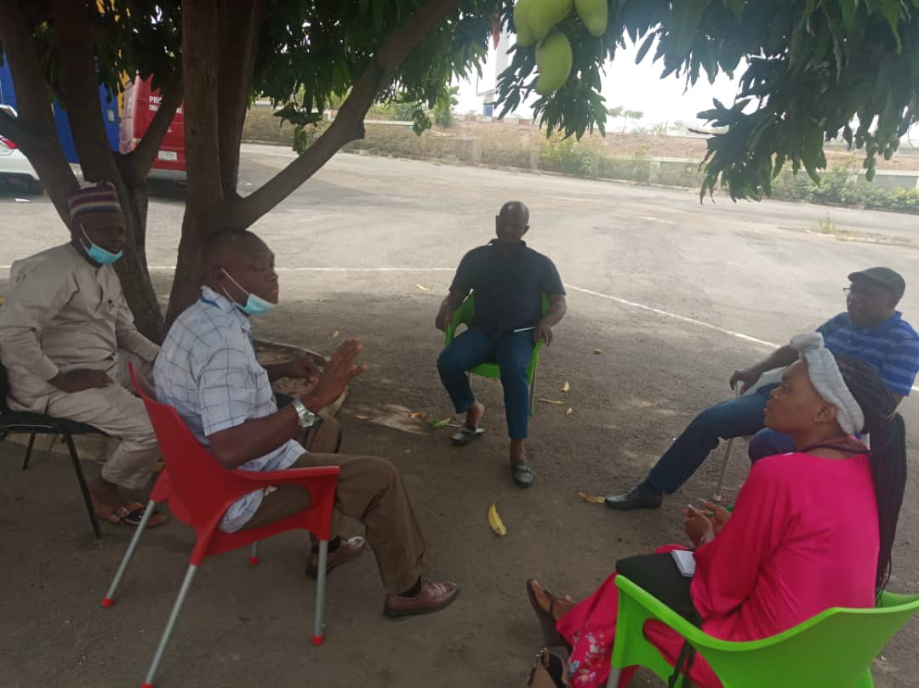

Methodology

This study is a qualitative exploratory study that used interviews, and documentation analysis to generate data. Information was gathered through in-depth, semi structured, one-to-one interviews and life histories of the respondents.

To carry out research that would be representative of the entire country and of persons with disabilities, the country was clustered into six regions. Fifteen States including the Federal Capital were selected for the study. A population-based, cross-sectional survey of persons with disabilities was used to select respondents that belonged to underrepresented group of persons with disabilities. Additionally, snowball sampling was used to locate persons. Referrals were made by organisations of persons with disabilities, disability leaders, and services providers. Furthermore, seven research assistants identified target groups in remote communities in different regions. In turn, 58 persons with disabilities from underrepresented groups were interviewed across five out of six of Nigeria’s geographical regions.

The research assistants had previous experience working with persons with disabilities. The research assistants included four women and three men. A month prior to their field visits, they reviewed the interview questions, gathered information, developed their strategies and identified logistics.

The interviews were structured around key issues in the areas of health, social protection, employment/ livelihood, and accessibility. The language of the interviews was held in English. However, in instances in which respondents did not understand English fluently, the researchers translated the questions into the local dialect. The confidentiality of the participants was upheld, and all images and photos used in this research had the approval and consent of the participants for use in this study.

The average age of the participants was 37 years old. The youngest participant was 17 years old, while the oldest was 79 years. Respondents represented a gender balance. Thirty-two of the respondents were female, while 26 were male. Five categories of persons with disabilities were surveyed in the study. They comprised 18 persons with physical disabilities, 10 blind and partially sighted persons, 10 deaf and hard of hearing persons, 12 persons with intellectual disabilities, and eight persons with psychosocial disabilities. Also, 62% percent of the respondents identified as having more than one disability. Respondents were from urban, suburban, ex-urban and rural communities in Nigeria. Ten respondents (17%) were members of organisations of persons with disabilities and 48 (83%) were not members of any organisation.

Data Analysis and Synthesis of Findings

The data collected was synthesised using thematic analysis and qualitative translation from respondent responses from interview questions.

The study found that:
- Fifty-two respondents (89.7%) expressed fear that if they contracted the COVID-19 virus, they would not receive life-saving procedures, or equal care to persons without disabilities.
- Fifty-four respondents (93%) indicated that their access to regular medical treatments and regular follow ups were impacted during the pandemic.
- None of the interviewees (100%) received any form of cash benefits related to COVID-19 from the government.
- Six respondents (10.3%), received food in different forms from their local government during the pandemic. These were mainly respondents from urban areas where food was handed out during the lockdown.
- All the respondents (100%) agreed that during the lockdown, their means of livelihood were disrupted. Most of the respondents (62%) included persons with multiple disabilities who received support from their families. Due to the lockdown, the families lost their livelihood and faced economic stagnation.
- On accessing information about COVID-19 vaccines, 24 respondents (41%) agreed that they learned about the vaccine from the news, their family, and friends. However, with regard to information on how persons with disabilities could access the vaccine, none of the participants had any information.

Daily Life
One of the interview questions was: “How has your mental wellbeing been affected by the pandemic?” Findings showed that the COVID-19 pandemic and the lockdown heightened psychosocial disabilities of persons with disabilities in Nigeria.

Forty-eight of respondents (83%) highlighted how the lockdown affected their mental wellbeing and caused anxiety and depression due to sequestration and fear of the unknown. One respondent said his disconcertment was caused by disquiet over the high cost of commodities and the “grounding” of his business during the lockdown. Another respondent said she was afraid that she might lose her friends as they might become used to the restrictions and adapt to it. A 42-year-old disability activist with polio said,

“I thought I was a strong woman, but the pandemic proved otherwise. I was getting so bored staying at home and not able to receive or visit people with whom I have formed an attachment.”

A 46-year-old respondent said that the “fear of the unknown” was the cause of her anxiety. With her supplies running out, no cash and unable to go out to find food, she could not predict what would happen next. A 30-year-old blind respondent explained how depressed she was because people were unwilling to socialise with her. She explained that people did not come to her to hold her hand and guide her as was the case before the COVID-19 restrictions. She noted that many people were afraid to be close to her and as a result she felt hurt and depressed.

Safety
Another portion of the interview sought to learn about the safety of persons with disabilities in their homes and communities during the lockdown. A question asked was “Are you experiencing any new kinds of violence due to the change in daily life activities?” Ten respondents, which is seventeen per cent of the total respondents surveyed, agreed that they experienced a new kind of “violence” during the lockdown. One 75-year-old participant with multiple disabilities was being supported by her son and daughter in law. She indicated that her grandchildren were teasing her and being disrespectful for overstaying her welcome.

A respondent with a spinal cord injury recounted how she and other women with disabilities once left their homes in search of financial assistance. They were stopped by security agents who were enforcing the lockdown. As they tried to explain their situation, they were manhandled by the agents who had orders to enforce the lockdown. Another interviewee shared that an unknown person stole the only food that they had from their home, which left the family with nothing to eat that night. This caused fear and anxiety in the family.

A young man with a physical disability visited his brother in a nearby city and had an unpleasant encounter with thieves. Since there was no transport during the lockdown, he decided to walk. The expedition was also a way to relieve himself of the stress of staying home all day. Unfortunately, on his way, he was attacked and his smartphone was stolen. According to him, this incident happened because his attackers noticed he was a person with a disability and could not easily fight back or run away.

A female respondent with an intellectual disability explained that because of the scarcity of food in her home, during the lockdown she and her siblings ate together from one plate. At every meal, her siblings would steal her food.

Emergency Plans
The research aimed to learn about the experiences of persons with disabilities regarding government emergency plans asking “Are emergency plan websites, official government announcements and documents accessible? If not, please explain.”

A respondent affected by Hansen’s disease had this to say:

“most of the persons affected by Hansen’s have little or no IT knowledge. We rely on friends or community members and outlets, for example, the radio. We therefore, cannot access information from websites.”

Another respondent observed that most of the women with disabilities in her community were not IT literate and unable to afford Android phones. As a result, the main source of information comes from the community. Other respondents shared that accessing COVID-19 information was not relevant because of lack of IT skills. One of these respondents said,

“This is not relevant to the majority of blind women because we lack the IT know how. We cannot afford phones that allow us to access the sites.”

Conclusion
This research made it possible to learn about the situation of persons with disabilities in distant parts of Nigeria during the COVID-19 crisis. The impact of COVID-19 has had a disproportionate impact of persons living in poverty, including persons with disabilities. It is imperative that it is recognised that all people deserve a planet which they can call home and have some measures of equality, keeping in line with the 2030 Agenda for Sustainable Development and its Sustainable Development Goals particularly during times of crises. Under the SDGs, countries have committed to take proactive steps to reduce poverty, extreme hunger, poor healthcare services, inequality in education, WASH, and other areas for the people in their countries. The CRPD also creates obligations on countries to promote, protect and fulfil the human rights of persons with disabilities, COVID-19 has highlighted much remains to be done. Positively, more countries, including Nigeria, are volunteering to present national reviews of the implementation of the Sustainable Development Goals at the United Nations, even when the COVID-19 pandemic presents a potent barrier.

Recommendations
Since the outbreak of the COVID-19 pandemic, the Stakeholder Groups of Persons with Disabilities, as well as the International Disability Alliance, International Disability and Development Consortium, the World Blind Union, and others have been gathering updated information on the experiences of persons with disabilities during the pandemic. These efforts have included persons with disabilities and their representative organisations through awareness campaigns, information sharing, and collaboration with governments. These efforts will help bridge existing gaps in policies and advance action-oriented plans to promote the rights of persons with disabilities.

To strengthen the work of the Stakeholder Group of Persons with Disabilities, the following recommendations are pertinent:

- Provide awareness campaigns to familiarise governments and their agencies about disability inclusive protocols;
- Share COVID-19 information in accessible formats for all persons with disabilities, and use all appropriate channels to disseminate the information;
- Encourage and support more research to identify additional barriers to the inclusion of persons with disabilities in the COVID-19 response and recovery efforts in the Global South;
- Collect and share accurate national disability data, which is key to achieving disability inclusion in government COVID-19 response toward sustainable development. The government should have updated statistics on persons with disabilities as this is crucial for planning, policy formulation and advocacy efforts;
- Official government COVID-19 websites should provide a contact person in all regions, and a disability COVID-19 liaison; and
- Strengthen inclusive education systems to help ensure that persons with disabilities are not excluded from virtual learning during periods of lockdown.

References
Elumoye, D. (2021): 20m Nigerians Will be Out of Poverty in Two Years, Says Osinbajo. Published in ThisDay Newspaper 19th/01/2021.

Kazeem, Y. (2020): Africa’s largest economy has suffered its worst contraction in over a decade. Quartz Africa.

Lain, J. and Vishwanat, T. (2021): Tackling poverty in multiple dimensions: A proving ground in Nigeria? World Bank Blogs

Nasir El Rufai (2021): Nigeria has highest number of poor people globally. Vanguard Newspaper 24/2/2021

National Bureau of Statistics, (2021): Nigeria’s population

NCDC, (2021): COVID-19 Nigeria. Assessed on 23/2/2021

Soto, A. (2021): Africa’s Largest Economy Unexpectedly Exists Recession. A Bloomberg Report.

Stakeholder Group of Persons with Disabilities for Sustainable Development, (2020): The experience of persons with disabilities with COVID-19 – A short qualitative study

Trading Economics (2020): Nigeria GDP. Accessed on 17th/01/2021

Umeh, N. C. and Adeola, R. (2012): Nigeria: Facts and figures on disability. Resolutions of the 14th regular meeting of the National Council on Women Affairs and Social Development held in Ado Ekiti, Southern Nigeria on 9 February 2012

Wikipedia, (2021): Sustainable Development Goals and Nigeria. Accessed on 25/01/2021

WorldOmeter (2019): Nigeria Urban Population. Accessed on 18/01/2021

World Bank, (2019): World Development Indicator: Nigeria

World Population Review (2020): Nigeria Population 2020 Live. Accessed on 18/01/2021

This document was prepared by Godwin Irokaba for the Stakeholder Group of Persons with Disabilities.
NCDC, (2021): COVID-19 Nigeria
The Federal Ministry of Humanitarian Affairs, Disaster Management and Social Development is the sole agency of the government that receives and distributes relief materials. This is the same Ministry that oversees the affairs of organisations of persons with disabilities in Nigeria. Notwithstanding this oversight duty, the Ministry did not distribute slots of palliative supports to organisations of persons with disabilities.
Nasir El Rufai (2021), ‘Nigeria has highest number of poor people globally.’ Vanguard Newspaper 24/2/2021 (accessed May 31 2021)
Ibid
Onyeji (2021), ‘Persons with Disabilities not benfitting enough from Social Protection in four Nigerian States’ (accessed May 31, 2021)

