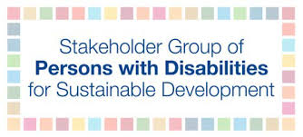

Key findings and recommendations on the impact of COVID-19 on

persons with disabilities in Bolivia

Content
Executive summary 2
Introduction 4
Methodology 4
Main findings of general aspects 5
Bolivian State Response 5
Challenges accessing social protection 5
Organisations working on disability inclusion 6
Observations and key findings 8
Daily life experiences 8
Safety 8
Living conditions 9
Healthcare 9
Social Protection 10
Employment 10
Emergency plans 11
Information and data 11
Advocacy participation 11
Vaccination 11
Conclusion 12
Recommendations 13
Annexes 15
Questionnaire used for interviews 15

Executive summary
The COVID-19 pandemic caused serious harm, distress and uncertainty to persons with disabilities. Despite an international framework for response, governments all over the world were unable to respond adequately and Bolivia was not an exception. Discrimination, exclusion and lack of proper protocols impacted the lives of millions of persons with disabilities.
The methodology used for this small-scale report included several in-depth interviews with persons with disabilities exploring the experiences they had and continue to have during the on-going COVID-19 pandemic in Bolivia. Ten key areas were identified to explore:

- Daily life, and how respondents felt threatened and were affected by the pandemic, isolation and changes in their daily routines. The difficulties encountered in the procurement of medicine and food. Negative attitudinal barriers. The impact on mental wellbeing, and other limitations.
- Physical security, most of the respondents were not affected in this area.
- Living conditions, the pandemic forced some persons with disabilities to join a wider family group. This caused some barriers and difficulties with roles in a new extended family and sharing a space.
- Health care, in general most respondents were concerned about contagion, because they know that protocols of care for persons with disabilities do not exist or are not respected, and this causes uncertainty and fear. Most of the regular medical services were suspended and COVID-19 information from the authorities was insufficient and inaccessible, which further complicated the already difficult situation experienced prior to the pandemic.
- Social protection, is a right, but in this crisis, the government did not collect enough information to be able to identify each case, so many were affected by lack of support from the State.
- Employment, many persons with disabilities lost their jobs and are now experiencing economic hardship, and. increased competition in obtaining new employment.
- Emergency plans, simply were not met. No specific protocols were developed for or applied to persons with disabilities. Governments need to put in place mechanisms that effectively protect persons with disabilities in future emergencies.
- Information, lack of information and data was a key issue. Most of the respondents indicated that there is not enough accessible and available information about COVID-19.
- Advocacy, there is a lack of sufficient advocacy and political participation of persons with disabilities. These must be promoted and strengthened in the national agenda.
- Access to vaccinations, although persons with disabilities are mentioned in the National Vaccination Plan, in practice adequate mechanisms have not been implemented to ensure persons with disabilities have access to vaccines.

Introduction
COVID-19 has severely impacted the world's economies and societies at large. Furthermore, this crisis has hampered countries’ responses to their commitments and progress on realising the rights of persons with disabilities, specifically in compliance with the Convention on the Rights of Persons with Disabilities. To better understand how the pandemic has affected persons with disabilities this research aimed to learn more about barriers that have emerged from COVID-19 and effects from government actions. To gain this information, qualitative research was conducted to learn and understand the lived reality from the perspective of persons with disabilities throughout Bolivia.

Methodology
This report is a qualitative exploratory research study with the objective to learn about the experiences that persons with disabilities experienced in Bolivia during the COVID-19 pandemic. The following processes were carried out:
- Desk Research: Research, data collection and document analysis was carried out to understand actions taken by official institutions in Bolivia, international organisations, and organisations of persons with disabilities during the crisis.
- Contact with networks: CBM Bolivia identified potential candidates to interview who were then contacted via WhatsApp for availability and interest.
- Questionnaire: A semi-structured questionnaire was developed that addressed 10 study dimensions and respondents completed this online.
- Interviews: Interviews were carried out virtually with respondents and unstructured interviews were also conducted with key informants to learn about general topics that were not included in the questionnaire.
From the originally contacted candidates, 9 responded positively and were interviewed, making this a very small sample and therefore this study does not claim to be representative of all views of persons with disabilities in Bolivia.
Four men and five women with disabilities were interviewed. Respondents came from different parts of the country including two people from Cochabamba, six from Sucre and one from Riberalta. The average age of the respondents was 36 years, with the oldest 55 and youngest 21 years old. Respondents represented different disability categories, including one deaf person, three persons with psychosocial disabilities, two autistic persons, three persons with physical disabilities and one blind person.

Main findings of general aspects

Bolivian State Response
Accurate information on how many persons with disabilities live in Bolivia is not easy to determine as there have been a number of problems collecting data over the years. The current estimate according to the Ombudsman's portal, is that there are 388,109 persons with disabilities in Bolivia. However, another estimate indicates that there are 95,884 people with disabilities in Bolivia.

Challenges accessing social protection
A significant barrier is that most public information is not provided in accessible formats, making it difficult for persons with disabilities to access and receive vital information about COVID-19 or other areas.
The SIPRUNPCD is an administrative registry of persons with disabilities in Bolivia. It is neither updated nor includes most persons with disabilities. Some of the interview respondents stated that the registry undercounts the vast majority of persons with disabilities who in turn are unable to access social protection services. One example is the Disability Bonus that is a monthly payment of 250 bolivianos (approximately 36.37 USD) for persons with significant disabilities. Some persons with disabilities only received the Disability Bonus once, and protested in order to receive this on a monthly basis as intended. Unfortunately, even in non-pandemic times, the Disability Bonus only reaches a portion of the population.
Persons with disabilities are included in some social protection programmes. Regarding the Family Basket programme, the Ministry of Economy and Public Finance indicated that 38,171 persons with disabilities and other marginalised groups were part of the programme, which was extended for three months to avoid crowds of people. The Renta Dignidad programme included 67,147 persons with disabilities and other marginalised groups.
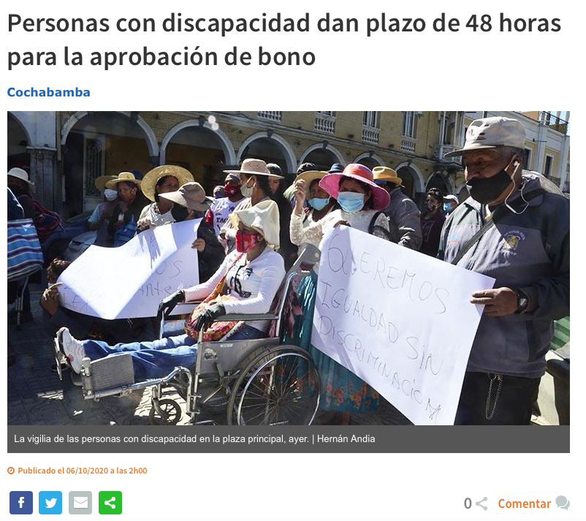

Organisations working on disability inclusion
The CONALPEDIS, or National Committee of the Persons with Disabilities, is the governing entity with regards to persons with disabilities in Bolivia. It has within its mandate, to monitor and regulate accreditation mechanisms and elaborate technical and scientific protocols that allow the inclusion and protection of the rights of persons with disabilities.
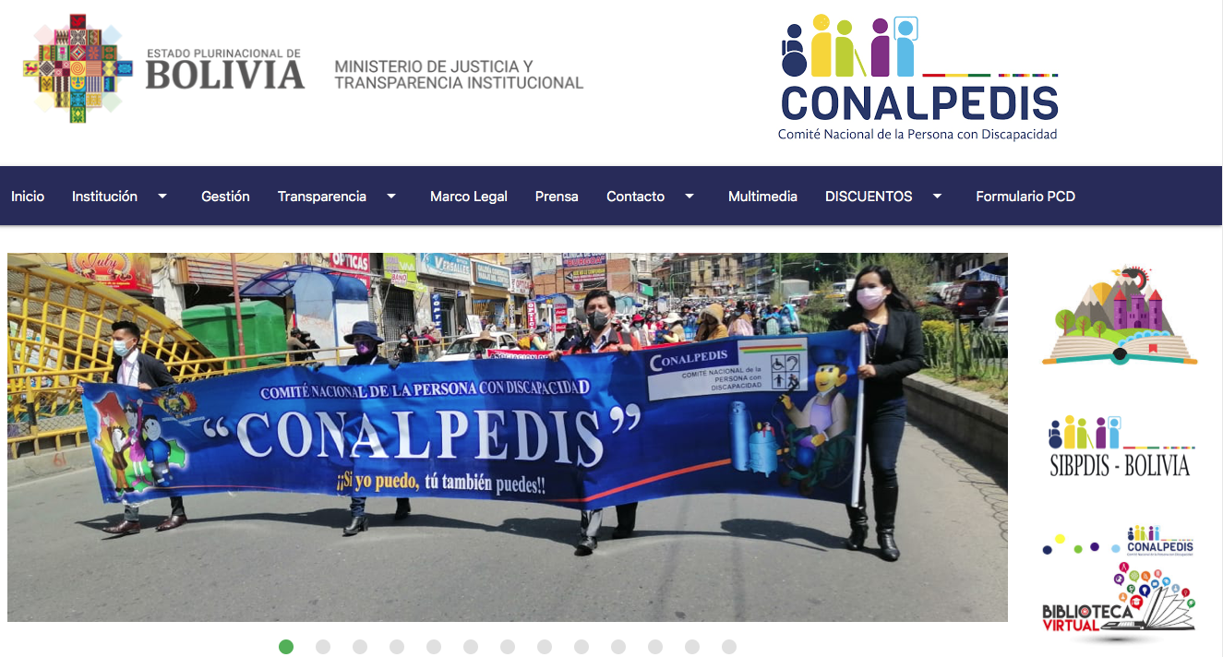
The pandemic has created extra challenges for many organisations of persons with disabilities. Respondents indicated that government actions and response during the pandemic have been inadequate in terms of including persons with disabilities. There have been violations of and non-compliance with the Convention on the Rights of Persons with Disabilities. Yet, positively, Bolivia has initiated a National Vaccination Plan, and in this, persons with disabilities have been briefly included. It is important to note that several rehabilitation centres for persons with disabilities have been opened, such as in Cochabamba and in the municipality of Santa Cruz.

Observations and key findings
The information collected presents a new perspective with regards to the experience that persons with disabilities in Bolivia, have had to face and live during the Covid-19 pandemic.

Daily life experiences
In general, most respondents indicated that their lives felt threatened by the pandemic and that they saw an increased risk to their health. A sedentary lifestyle mainly affected wheelchair users, but also persons with intellectual disabilities who experienced isolation causing increased stress.
The vast majority interviewed encountered negative attitudes or increased discrimination, particularly because of lack of social contact. This mainly affected children with disabilities, but also many neighbors did not understand some of the behaviors exhibited by some persons with psychosocial disabilities, which could cause tension. Some respondents expressed increased anxiety and lack of sleep. Others indicated that their lives had become dull and monotonous, especially for those infected with COVID-19. People’s daily routines changed both in terms of schedules and with limited access to physical activities.
Almost half of those interviewed (44.4%) had challenges accessing food and clean water, which indicates the need for more effective social protection systems. Some respondents had no issues accessing clean water to wash their hands, and some used anti-bacterial gel to wash their hands. In relation to obtaining personal protective equipment (PPE), 75% had no difficulties getting PPE, however, 12.5% were not able to get PPE due to lack of financial resources. For some persons with intellectual disabilities, it was difficult to put on and wear personal protective equipment, and some deaf people’s PPE interfered with their hearing aids.
Accessibility barriers and the lack of systems in place to identify persons with disabilities shows that persons with disabilities are more marginalised and at risk in emergencies such as the pandemic. To address this, it is important to develop administrative records to provide data on persons with disabilities, as well as to be able to provide the necessary assistance when required.

Safety
Respondents overall did not feel that they were more at risk for crime due to having a disability.

Living conditions
The respondents highlighted that the pandemic did change the living conditions for many persons with disabilities in Bolivia. One main change was with extended families and the subsequent new family roles. This change caused stress, concern, and tension among smaller family units. In some cases, grandparents became guardians to school-age children and property consumption costs and utility bills increased. At the same time, family ties were strengthened from these changes and the pandemic positively forced families to learn how to cope better with uncertainty.
More than half of respondents said that the pandemic made it more difficult to live independently because of the strict restrictions and because of the lack of responsibility mainly from spouses. When asked if the pandemic had impacted vital services, such as personal assistants, 57.1% said no, 28.6% had been impacted and the remaining 14.3% did not know. More than half of the respondents were unaware of the situation of persons with disabilities in institutions. Likewise, the vast majority interviewed were unaware of how the pandemic had affected internally displaced persons or refugees with disabilities.

Healthcare
The vast majority (78%) of respondents were concerned that if they were infected with COVID-19 that they would not receive proper life-saving procedures, or at least the same treatment as persons without disabilities. Similarly, most respondents were unaware of any policies that might assist them in receiving treatment equally to others. Only 33.3% were aware of the kind of treatment they would receive.
Regarding healthcare settings (clinics, health centres, and hospitals), almost 80% indicated that they did not have sufficient information or access to reasonable accommodations such as access to a sign language interpreter. Some respondents indicated that they were constantly being ill-treated in healthcare settings. When asked if they could be accompanied by a personal assistant or sign language interpreter in medical settings, most respondents expressed no knowledge as there were no clear instructions or information about this process. In procuring medicine and medical supplies, several stated that pharmacies provided them with supplies, but others shared that it was a difficult and complicated. But most indicated that their access to regular medical treatments or follow-ups had been affected by the pandemic.
Again, a significant challenge was that vital information related to COVID-19 was not reaching persons with disabilities due to lack of dissemination to communities and not being in accessible formats.

Social Protection
Social protection encompasses a variety of policies and actions in different areas. The majority of respondents (88.9%) indicated that social protection measures had worsened and regressed.
Most respondents stated that they were unaware of available social protection benefits, but others knew about the bonds (unconditional monetary transfers) and the family basket. Out of the respondents, 44.4% had received a bonus versus 44.4% who receiving none and 11.1% had received the bonus once. This contrasted with 88.9% who were unaware of new programmes to ensure their safety in the pandemic. However, 66.7% received some support from their local government. The rest had not received support or were unaware.
There was no defined or clear policy on how central and local governments could provide this support. There was lack of information on how supports were to be dispersed. Again, a key barrier in receiving support was from the lack of an updated registration system with all persons with disabilities registered.

Employment
Persons with disabilities and their employment and livelihood in Bolivia were directly and adversely impacted. Many layoffs generated great concern and anxiety for persons with disabilities. The few cases in which persons with disabilities maintained their jobs did so with great risk and many difficulties such as lack of transport and with little consideration toward their circumstances.
In Bolivia, the labour gap between persons with disabilities and those without disabilities remains significant. Barriers to participation for persons with disabilities in the workforce have only increased by being forced to work at home. Lack of income has exacerbated poverty rates of persons with disabilities, and furthermore now have to compete in the labour market with more persons without disabilities who have lost jobs, further complicating the situation. It is therefore important that public policies for obtaining employment are developed that are truly effective.

Emergency plans
All of the respondents were not able to access COVID-19 emergency plans, either locally or nationally. Moreover, emergency numbers, websites and documents related to COVID-19, were often not in accessible formats. Furthermore, emergency personnel were not trained on how to share information with persons with disabilities, and in general, emergency plans were not accessible. It is important that for next emergency, plans are drawn up in accessible formats in compliance with the Convention on the Rights of Persons with Disabilities.

Information and data
Most respondents stated that there was not enough information and data at the national level related to the pandemic and persons with disabilities. Also, the existing information is not available in accessible formats. This is an area that needs to be strengthened.

Advocacy participation
More than half of the respondents (55.6%) were not of part of any advocacy efforts to influence decision-makers to include persons with disabilities in COVID-19 responses. Respondents shared that it is extremely difficult to reach persons responsible for decision-making. Some stated that the process has been highly politicised and that governing institutions are part of the government, and rather than facilitating the processes, they complicate it.

Vaccination
When asked if the government shared any information or plans on how persons with disabilities could access vaccines in Bolivia, 88.9% said no, and 11.1% said yes. Most participants indicated that they do not plan to get vaccinated, mainly for fear of subsequent effects, but also for the lack of adequate information regarding the vaccine. Some persons with disabilities suggested that pandemic and vaccine information should be printed in Braille and other accessible formats, indicating that the vaccine is safe, necessary, and widespread.

Conclusion
The research from this small scale study highlights that the situation for some persons with disabilities in Bolivia is complicated. The Convention on the Rights of Persons with Disabilities is not being realised and the pandemic has exacerbated barriers for persons with disabilities. There are increased barriers and new barriers including lack of access to information on COVID-19 and the lack of inclusive strategies and programmes to support persons with disabilities in this crisis.
To address the barriers that persons with disabilities face there needs to be increased space to ensure meaningful participation of representative organisations of persons with disabilities. Communication and participation mechanisms for persons with disabilities need to be created and strengthened.

Recommendations

- It is important to develop a strategy for persons with disabilities to get access to vaccines and to have information about vaccines. This is particularly important in rural areas where persons with disabilities have less access to information on COVID-19 and on the efficacy and effects of the vaccine.

- It is recommended that further investment is made to ensure meaningful participation of all diverse disability groups in CONALPEDIS. Furthermore, it is highly desirable that across all activities including in the leadership of CONALPEDIS that gender balance is secured as well as particular attention is given to the most underrepresented groups of persons with disabilities.

- To advance the disability rights agenda in the Bolivia, further investment is needed to ensure the disability rights movement can work together ensuring full engagement in government policies and programs.

- To realise the SDGs, the government has to include the most marginalised groups including persons with disabilities in their programmes and policies, including in emergency plans.

- Data on the situation on persons with disabilities needs to be collected to address barriers and to for evidence-based policymaking.

Annexes

Questionnaire used for interviews

Introduction
Good morning and thank you very much for your willingness and support. This project aims to gather information on the impact that the COVID-19 pandemic has on persons with disabilities in Bolivia. The results will be linked to the relevant sustainable development goals (SDGs) with action-oriented recommendations.
We will maintain your confidentiality by changing names, locations and/or identifying features in our final report. Please note that you will not be compensated for participating in this interview. Their answers are very important as they can help on the issue of long-term disability.
Personal Information:
What is a full name?
Where do you live? (Include city):
Do you live in a rural, urban area?
How old are you?
What is the gender (male or female)?
What is the type of disability?
Are you a representative of an organisation of persons with disabilities, NGOs, academia or another group?
Provide your email address:
In the next section, we'll ask COVID-related questions by topic.
Life
- Is your life threatened by the pandemic or has it created an increased risk to your health and disability? If yes, please explain:
- Have you experienced any negative attitudes or increased discrimination toward you in your community or anywhere else during the pandemic?
- How has your mental well-being been affected by the pandemic?
- Because of the pandemic, did you have difficulty accessing food or clean water? Or has the pandemic increased this difficulty?
- If you don't have access to clean water, how do you wash your hands?
- Do you (or had) difficulty obtaining personal protective equipment (PPE), such as a mask, gloves, or gown? And, did you have difficulty using or putting on PPE? If yes, please explain.

Safety
- Do you feel more vulnerable or at risk of crime? If yes, explain why
- Are you experiencing any new types of violence due to the change in the activities of daily life? If yes, where? (e.g., at home, on the street).

Living conditions
- How have the roles of family members in your home changed because of the pandemic? Are there new or additional responsibilities, such as parents being teachers of their children.
- How has a shared living space with extended family members affected you and your home?
- Has the pandemic made it harder to live independently? If so, how?
- Has the pandemic impacted vital services as personal assistants?
- Do you know what's happening to persons with disabilities who are in institutions?
- Do you know how the pandemic has affected internally displaced persons with disabilities and refugees with disabilities?

Healthcare
- Are you concerned that if you hire COVID-19 that you will not receive life-saving procedures, or you will not receive others equally?
- Are you aware of any policies in which you live that affect you in receiving treatment equally to others?
- In healthcare settings, can you fully access information, for example through language interpreters? If not, describe what the situation is.
- Can a personal assistant or sign language interpreter accompany you in health care settings? If not, describe what the situation is.
- Can you access hospitals for non-elective surgeries or treatment or even life-saving procedures during COVID-19?
- If you need medications or other medical supplies, how do you get these items during on-site confinement situations?
- Has your access to regular medical treatments and regular follow-ups been affected during the pandemic?

Social protection
- Have social protection measures in your country changed, such as previous policies getting worse or backwards?
- Are social protection benefits being provided? how?
- Have you received any cash benefits related to COVID-19?
- Have new measures been put in place to ensure their safety?
- Does your local government provide you with any support during the pandemic (e.g., food or drug delivery)?

Employment
- How has the pandemic affected your employment opportunities and livelihoods?
- If you are working remotely, have you found accessibility barriers? If yes, please explain:

Emergency plans
- Have you been able to access your national and/or local COVID-19 emergency plans?
- Are emergency plan websites, official government announcements, and documents accessible? If not, please explain:

Data
- Please share any resources on data at national level and COVID-19, related to persons with disabilities and/or general information:
Advocacy
- Is it part of any advocacy effort to influence decision makers to include persons with disabilities in responses such as access to information, access to social protection, and/or access to vaccines?
Vaccines
- Has your government shared any information/plans on how persons with disabilities can access the vaccine in your country?
- Have you found barriers to accessing vaccine information and/or receiving the vaccine? If yes, please explain. Negative comments regarding the vaccine.
Provide any other information you want to add.
Thank you very much for your time and collaboration!

This document was prepared by Ramiro Nóchez-McNutt for the Stakeholder Group of Persons with Disabilities. The research was carried out remotely from Guatemela.
At the time of this publication, Bolivia has had approximately 368,474 cases of COVID-19 and approximately 14,471 COVID-19-related deaths (Worldometer, accessed May 31, 2021).
See CRPD/C/BOL/1 pg.6
See Defensoría del Pueblo. According to data from SIPRUNPCD and the IBC there are 95,884 persons with disabilities of which 45% are women and 55% male.
Los Tiempos, June 2020.

