Citizen-Generated Data:

The Las Pinas Persons with Disabilities Federation, Inc. (LPPWDFI) Case
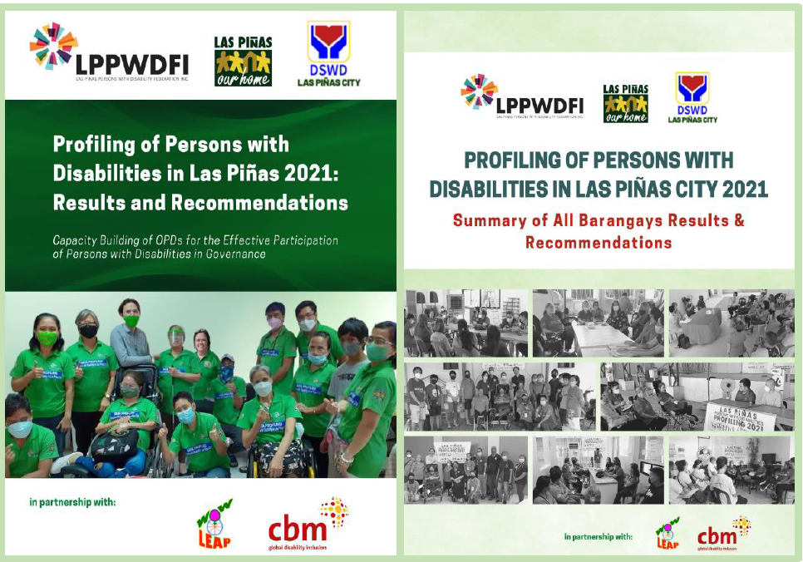

Title of the case study:
Profiling of Persons with Disabilities in Las Pinas City 2021
(This disaggregated data profiling for persons with disabilities is a component of CBM GLOBAL Philippines’ “Capacity Building of OPDs for the Effective Participation of Persons with Disabilities in Governance” project funded by CBM Australia)
Location: Philippines. National Capital Region (Metro Manila). City of Las Pinas (all 20 barangays).
--------------------------------------------------------------------------------------------

Link of the case study to CBM Global’s data advocacy priority.
This Case Study is aligned with CBM Global’s data advocacy key principles:
- We commit to leaving no-one behind, this is reflected in both our vision and mission statement and in our programmatic strategy and programme quality framework.
- We are journeying as an organisation on the appropriate and effective use of data disaggregated by disability to improve gaps in our programmes with respect to groups left furthest behind.
- We align with the principle of the importance of community and citizen driven data, particularly in a humanitarian context.
- We support advocacy initiatives that call for inclusive data that promotes transparency, but also recognise the need for protection and confidentiality; and
- We recognise the need for strengthening our organisation’s data skills and we recognise this is also critical for our partners.

Main impact seen from this data advocacy work.
*At the national level, the Executive Director of the National Council for Disability Affairs (NCDA) plans to adopt this profiling initiative by requiring the different OPD Federations in the National Capital Region and other regional OPDs to conduct similar initiatives with support from NCDA and LPPWDFI.
*At the local level, a one-day event during the National Disability Prevention and Rehabilitation week (July 17-23, 2023) is allotted for the presentation and commitment signing for the adoption by all 20 villages’ local officials to implement the recommendations of the study.
*Stronger/evidence-based advocacy by LPPWDFI for appropriate budgets, programs and projects with the City Government and its different departments, as well as for the Focal person for the disability sector of the City Social Welfare and Development Office.
*Much aligned programming by LPPWDFI for the disability sector (children, youth, women, and men with disabilities).
*Improved LPPWDFI’s data gathering and analytical skills on citizen-generated data which led to much improved prioritization of programs and services for the sector.
*Aroused the interest of other OPDs in Metro Manila/National Capital Region in conducting an OPD-led Persons with Disabilities Data Profiling for their own advocacy and programming.
*Inspired a multisector approach (public, private, universities, etc.) to cover areas not included in available financial resources (from CBM Global).
*Better access of national program and funding support from national government agencies (NGAs) to include programs for persons with disabilities (bigger budgets based on the Mandanas Ruling, TUPAD/employment by the Department of Labor and Employment; Social Protection by the Department of Social Welfare and Development; Universal Health Care by the Department of Health).
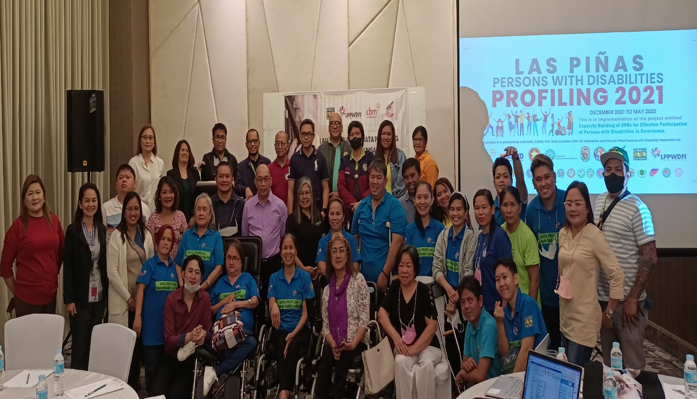

Description of case study

Background/Situation
LPPWDFI implemented the 2013 profiling of persons with disabilities in partnership with DSWD NCR. 2 fundamental gains: (1) collective experience contributed to strengthening the organization at the village associations and Federation level, and (2) the data generated provided strong evidence for policy and program development at the village and city-level. Building up on this gain, the profiling was expanded and has been updated in 2021-2022 with funding support from CBM Global.

Process of the data profiling
The following process has been adopted: 1. Setting up a Profiling Team 2. Write-shop 3. Selection and Orientation of data collectors and encoders 4. Lobbying (getting buy in and support) with different stakeholders 5. Actual data gathering 6. Initial assessment, Midterm evaluation, Final evaluation 7. Data analysis and Results 8. Presentation of Results and Recommendations to Stakeholders 9. Adoption of the Data Profile by the Persons with Disability Affairs Office (PDAO).

*Note that the questionnaire was adopted by LPPWDFI from the Department of Health’s Philippine Registry on Persons with Disabilities (PRPWD) which expanded the functional limitations questionnaire of the WGQ short set while LPPWDFI included other information that they considered very important to be able to understand the current situation of all Persons with Disabilities in the City of Las Pinas and come up with appropriate and relevant policies, programs, and budget.
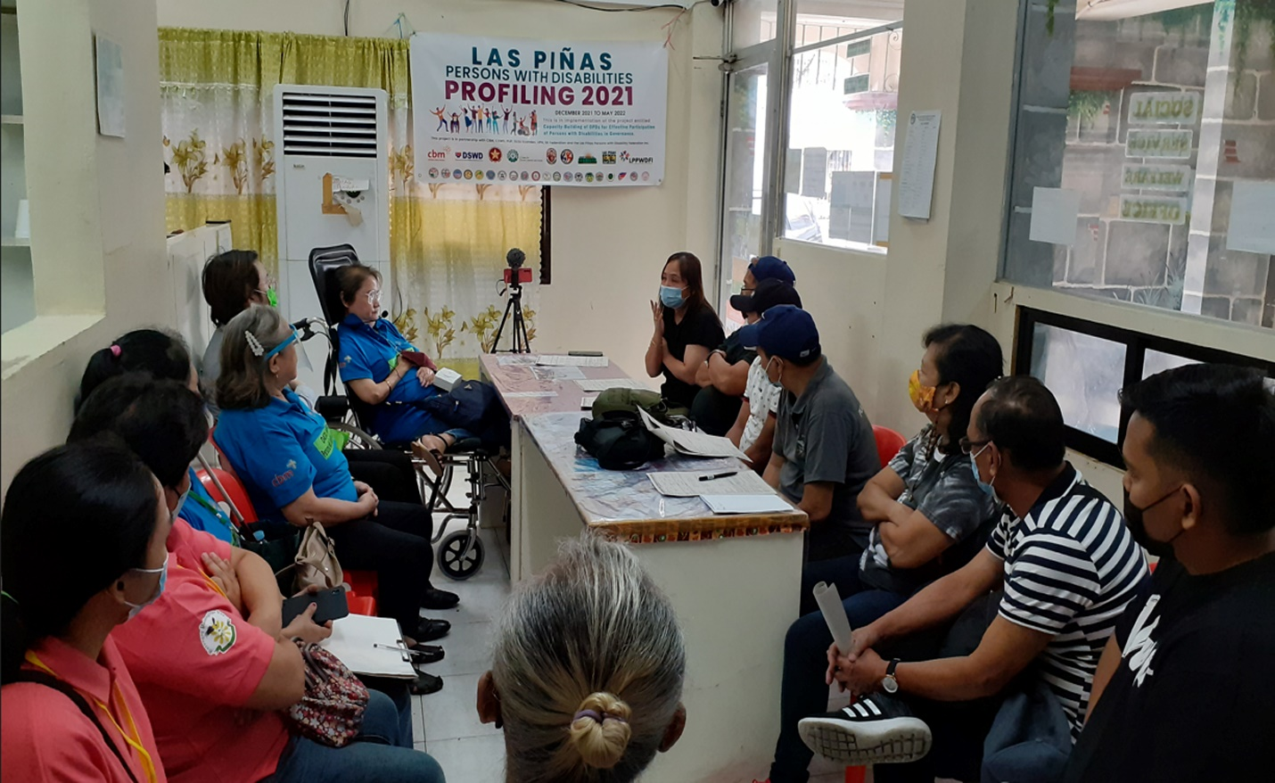

Persons with Disabilities’ involvement
- The LPPWDFI Profiling Team consisted of 4 Data Managers from the OPD city federation, 4 Data Coordinators from each cluster of villages, 3 Video Documenters also coming from OPD federation, Data Collectors are the Association Officers of the 20 village associations and volunteers from the academe.
- There was more participation from women, with and without disabilities, since there are parent/guardian volunteers, majority of whom are mothers. The federation is a cross disability barangay/village-based organization, this is why they have volunteers from different disability groups.

Summary of Action/Approach
The project revolved around participatory research wherein persons with disabilities were the main actors from planning, execution, to analysis of the research. The data gathering used video documentation for easy review and evaluation. The villages were composed of different homeowners’ associations (HOAs) including informal settlers. Different channels had been tapped to reach out to them including HOA/satellite registration, house-to-house, telephone, online registration, community activity with announcement using megaphones. The OPD has a strong sense of ownership of the project as the leaders themselves are mobilized as enumerators. They became more familiarized with the situation and the needs of their members. The local government units have been involved at the very start of enumeration starting the activities with a courtesy visit and commitment of village leaders to support the profiling activities in their area.

Key Results/Outcomes of the data profiling
*All 20 villages now have disaggregated data by disability / profile of persons with disabilities (name, age, address, type of disabilities, education, health, employment status, etc.)
*Identified 7,221 and successfully encoded 5,877 persons with disabilities. The data can be migrated to the Philippine Registry for Persons with Disabilities (PRPWD) for batch uploading that makes it easier for LGUs/OPDs to access PhilHealth/insurance services.
*Mobilized 131 OPDs and community volunteers to implement the project.
*Updated the status of engagement of persons with disabilities in their respective communities. More than half of the barangays have set up persons with disabilities offices; all 20 barangays/villages have Persons with Disabilities Assistance Desk with a salaried coordinator who is also a person with a disability or a guardian; village OPDs are now engaging into LGU activities like in Barangay Development Councils, Local Peace and Justice System, Health Councils, etc., not just the city federation OPD. Some Barangay LGUs have Barangay Committee on Disability Affairs.
*Formed partnerships with NGOs to access services not readily available in the LGU e.g. recipients of assistive devices (wheelchair both basic and modified, crutches, white canes, walking canes, hearing aids).

Unintended outcomes
*All persons with disabilities surveyed were provided with Pamaskong Handog (a Christmas gift from the LGU)
*Children with disabilities with their parents were treated to a day-out at a theme park (Enchanted Kingdom) funded by the LGU.
*Able to identify active OPD officers in each association.
*OPD Officers involved in the data profiling were awarded with a plaque of recognition during the National Disability Prevention and Rehabilitation (NDPR) Week.
*OPD leaders were tapped to give disability sensitivity training to the academe/schools.
*LGU provision of accessible transportation mobile service to OPDs. City Councilors are now providing accessible e-bikes to the villages that can load wheelchairs/or those with mobility or physical disabilities.
*City Social Welfare and Development Office collaborated with the City government offices to provide more disability relevant/inclusive programs and services based on the results of the study.

Key learnings and/or recommendations for others to consider.
*Importance of data on policy making, budgeting, and programming. The data served as evidence of the number and status/situation of persons with disabilities in the city. Results of the profiling became an eye opener for the local government officials, local policy makers, and government agencies.
*The use of online survey tool (Kobo Tool instead of Google platform) to discard papers and to get easy results. The use of pen and paper still required additional time for re/validation (especially when it is not readable), data cleaning, and encoding. This also required more time to coordinate with the partner academe/schools.
*Availability of gadgets/tablets/mobile phones during interview and data encoding equipped with language translation into local dialect. Compatibility of equipment on the use of Kobo Tool and Google platform. Some gadgets are not compatible with Kobo Collect app.
*Preparation of enumerators, those with and without disabilities (OPD leaders, parents/guardians, other volunteer groups) must include disability sensitivity training and self-awareness session to prepare them psychologically.

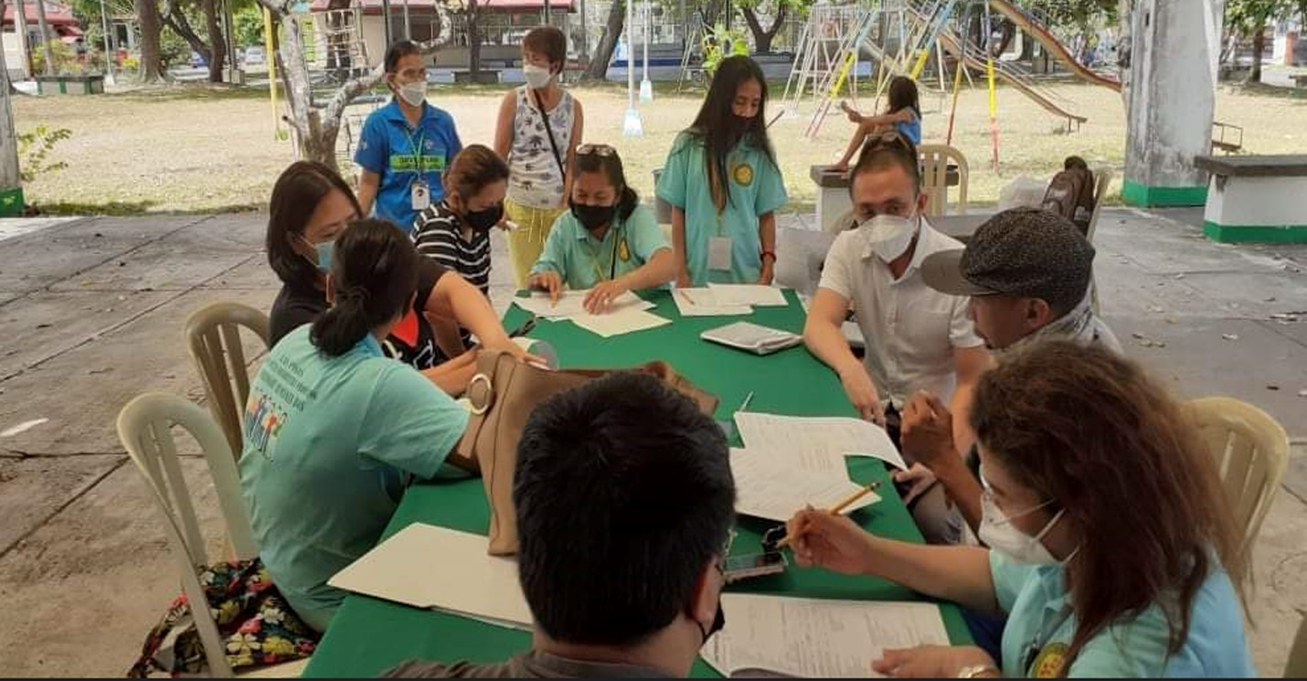

Key factors that facilitated the success of the data profiling
*Strong partnership with the academe/schools where they were tapped to facilitate the training on video documentation and encoding of data; students were also tapped as encoders of the results of the data survey form.
*Strong partnership with barangay LGUs (BLGUs) and Homeowners’ Associations (HOAs). HOA provided venues and food for enumerators while BLGU provided transportation support.
*Disability responsive and accessible facilities were offered among enumerators e.g. courtesy visits to BLGUs were done at the lower ground, basketball courts were converted into satellite registration.

Key data advocacy messages from this case study
*Active engagement of persons with disabilities in the data profiling process makes the initiative more meaningful to the sector and increases ownership.
*Evidence about the situation of persons with disabilities generated through the survey can be used in improving and aligning policies, budgets, programs, and projects, to make it relevant and appropriate for the rights and needs of persons with disabilities.
*Evidence generated through the study are effective tool in awareness building and advocating for appropriate and relevant services to persons with disabilities to local officials, government agencies and the private sectors and CSOs who are engaged in disability-related initiatives. Examples include: 1) service delivery of the unconditional cash transfer program to poor families (a poverty alleviation program of the Philippine Government) were able to identify families with children with disabilities who were excluded from the list are now being assessed for possibility of inclusion to the program; 2) Those Persons with Disabilities identified in the study without the ID are now in the process of getting IDs and included in the PRPWD (Persons with disabilities ID are needed to get 20% discounts in public/private transport and services like restaurants, hotels, airfares, etc. and 5% discount on basic needs/groceries; while if they are listed in PRPWD, are entitled to the Universal Health Care package of the Philippine Health Insurance (PhilHealth). 3) INGOs, NGOs, and CSOs are now able to develop appropriate, relevant, and timely projects in the city due to the availability of the data because of the profiling.
*A multi-sector approach in designing, implementing, analyzing, and validating/reporting the results is key to the buy-in of various sectors engaged in the initiative.

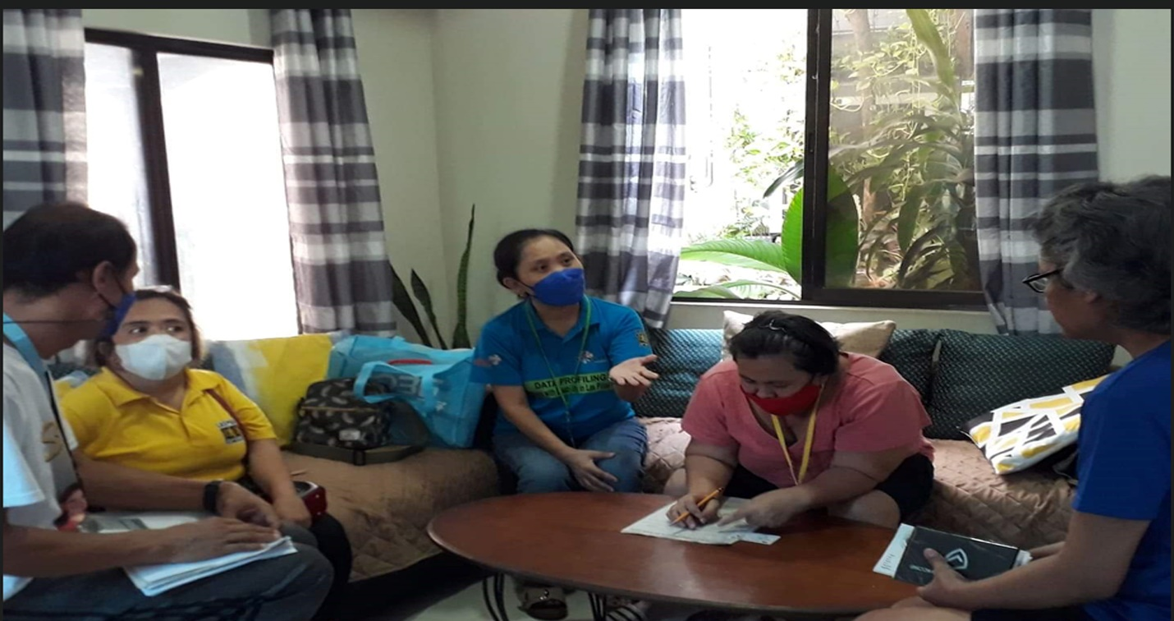
Progress to Date after the presentation of the data to Stakeholders:
- Scheduled presentation of printed profile to Barangay League (organization of all barangay captains/chiefs in the city).
- Copies were provided to all government offices of LGU. LPPWDFI has participated in city planning activities, DRRM planning and quarterly meetings, school board meetings, health board meetings, formulation of 5-year plan project of Las Pinas (Executive Legislative Agenda), accessibility task force, and gender and development planning for the inclusion of persons with disabilities.
- Inclusion of families of persons with disabilities in the 4Ps (conditional cash transfer program of the government-social protection). For those families who will be delisted, priority will be given to families with children with disabilities as replacement.
- Department of Labor and Employment (DOLE) and Public Employment Service Office (PESO) committed to address unemployment through their livelihood programs like TUPAD (Tulong Pangkabuhayan sa mga Disadvantaged Workers) livelihood program. PESO will include youth with disabilities in the Summer Program Employment for Students (SPES) program.
- Linking social welfare services with health services e.g., children with significant disabilities be given medicines for pneumonia for free
- Advocacy on accessible transport – PINOVATION. Advocating for LGU to support accessible transport to increase employment among people with disabilities.
- Organizing and training a core group among youth with disabilities to be part of mainstream youth organizations; and train them as second-generation leaders and be represented in LPPWDFI and participate in their programs and projects. As per the result of the survey and the profiling activity, potential youth leaders were identified, and a youth development program will be developed.

