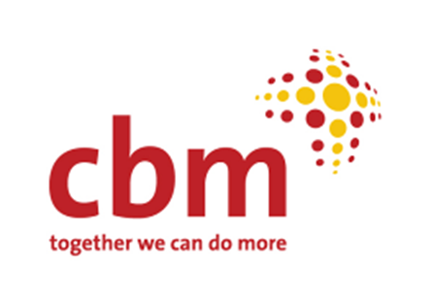

**Community Mental Health**

**Initiative Plan**

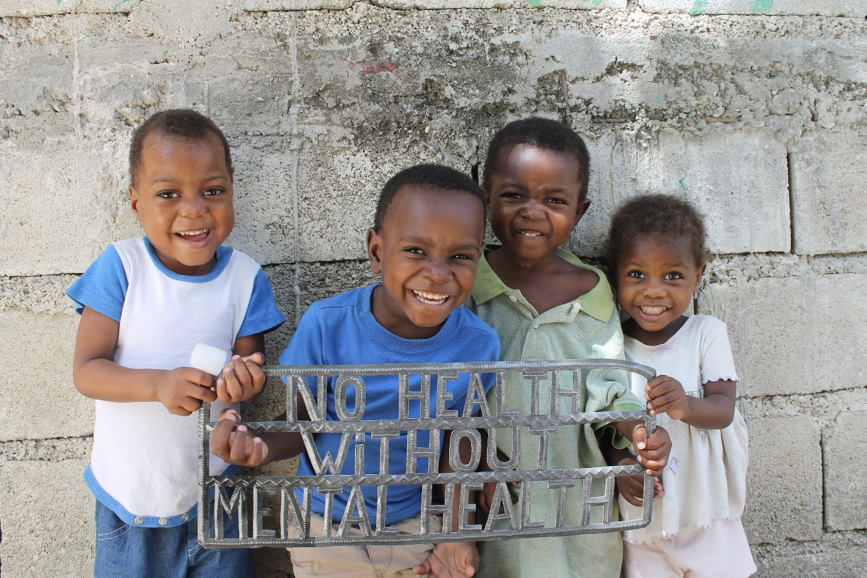

© Anna Kagstrom, 2015

**Contents**

**1.** **Executive Summary** 2

**2.** **Introduction** 3

**3.** **Background** 4

**4.** **Context analysis** 6

**5.** **Participation in the Initiative development** 8

**6.** **Underpinning principles** 9

**7.** **CMH Initiative Priorities** 10

**7.**  **Building an evidence base for piloting, scaling and influencing** 13

**8.** **Priority countries** 14

**9.** **Human Resources and structures** 16

**10. Financial Resourcing** 17

**11.** **Quality Assurance. Monitoring, Evaluation and Learning** 19

**12.** **Internal and external communication** 20

**12.** **Alliances and advocacy** 20

**13 Conclusion** 21

**Annex 1:** **Glossary of acronyms** 21

## **Executive Summary**

Mental health is core to overall wellbeing and to improving the lives of people with disabilities, their families and communities at large. It is also an essential contributor to successfully achieving wider social and economic global development objectives. The CBM Community Mental Health Initiative will bring focus and scale to the work that CBM does in order to have a greater impact on this area of growing interest in international development.

CBM has a legacy of 15 years of work in Community Mental Health (CMH), during which time the work has become integral to our international programmes.

The launch of the CBM CMH Initiative comes at a promising time of increased interest and prioritisation for mental health. This is framed within a clearly established place for mental health in the Sustainable Development Goals (SDGs), the global WHO Mental Health Action Plan, the Convention on the Rights of Persons with Disabilities, and a number of other commitments from countries, civil society, and global multilateral and bilateral agencies.

*The Initiative aims to promote meaningful participation in communities, improve quality of life, and improve choices for care available for people with psychosocial disabilities.*

CBM takes a rights-based approach to mental health and psychosocial disability, and has a particular reputation for working across the health and disability sectors. This means thinking about facilitating access to rights including justice, education/livelihood, housing, family life, and participation in community, in addition to improving access to health and social care. This is a key principle, which is growing in importance, and is a strong proposition on which to build the Initiative. It is also aligned to CBM’s internal principles and the Federation Strategy.

*The Priorities for the Initiative are*:

1: Strong voice of people with psychosocial disabilities *– the foundation of our work*

2: Community inclusion and participation

3: Strong and person-centred systems (including health systems)

4: Mental health is mainstreamed across sectors, including humanitarian settings, other areas of health and disability, and livelihood

*Each of these priorities has indicators for success and targets to achieve between 2019-2023. We have also* systematically *identified 11 priority countries* for the Initiative, where we will focus our work.

We will achieve these priorities by building on our experience and that of partners. *We will evaluate 7 specific models of work* that we have refined and believe to be impactful and cost-effective. We will document these for better dissemination in CBM and externally, and the Initiative will aim to have a full suite of these interventions in one country in each CBM region by 2023.

*The Initiative will be effectively overseen by a more cohesive Core Initiative* *Team* made up of Global and Regional Advisors, an Initiative Director. We will follow revised processes in CBM, particularly working closely with country offices and Member Associations as a technical advisory team (3-way collaboration), and there will be significant investment in advisory capacity at local level.

*Effective communication with other parts of CBM and external partners* will be achieved through use of CBM’s communication channels including social media, newsletters and webinars, as well as CMH Initiative Communities of Interest and Practice and direct communication.

We have focused on a small but influential set of Alliance partners. We will continue our strong link with WHO and global DPO representative organisations, and invest time in engaging with new actors in Global Mental Health. This will allow us to reach more people than would be possible by only working in the field with partners, and to influence the wider direction of the field, for example emphasising more inclusive approaches.

*We will resource the work* by closely liaising with Member Associations in order to both refine our messaging for direct fundraising to individuals, and to position CBM as a trusted partner in the ‘new world’ of Global Mental Health and the increased institutional resources expected to flow through this.

## **2. Introduction**

As CBM approaches 15 years of work in the area of mental health, we have the unprecedented opportunity to capitalise on the growth of interest and opportunities for funding in this area of inclusive development, and to build on our already strong foundations.

Through this Initiative, we will further establish CBM as an important global player, making a meaningful contribution to increasing prioritisation of MH as a global development concern within the SDGs. There is good reason to believe that funding is likely to increase substantially for mental health globally. *The Initiative will position CBM as a proven entity with the track record, capacity and expertise to deliver evidence-based change at scale with increased opportunities for growing our funding and impact in mental health.*

This plan is the result of extensive consultations within CBM, through our partners and alliances, and an examination of the current context and trends in the wider world of global mental health, psychosocial disability, and international development. It recognises the foundations built on our work in the field, including in humanitarian contexts and Community Based Inclusive Development, as well as engagement with governments in systems strengthening.

The plan starts with a background to our history in the field, an analysis of the current context in which we want to work, and the views expressed during our consultation and survey about the way that we should work in the future (the ***why***). We then share the outcomes of the participatory planning process we undertook, taking these contextual elements into account and incorporating the views of a diverse group of our stakeholders. This resulted in a set of priorities and objectives for growing this work in volume and quality (the ***what***). Finally, we look at how we propose to resource this work, in terms of ensuring the management and delivery structures of the Initiative are fit for purpose, that we are able to resource both these internal processes, and crucially, the scale up of programmes that would allow our partners to reach more people with impactful, quality and accountable work (the ***how***).

**WHY**

## **3. Background**

CBM uses a rights-based approach to address the barriers that people face in communities and structures that prevent them from participating fully in society. This means seeing people as deserving of rights rather than as merely recipients of charity and dependent on the decisions of those in power. We recognise that there is a need for transformational change in society towards inclusive and resilient communities where people with psychosocial disabilities can participate and contribute meaningful.

As part of this ambition, we work to improve access to services and to facilitate reform of countries’ health, education, civil society and other systems so that they promote good mental health, provide effective and dignified care to reduce the treatment gap, giving people a choice of care options that suit their needs, and promoting access to rights.

In all of this, we have placed the voice of people with psychosocial disabilities in the centre of what we do, recognising their essential role in bringing about change, and directing processes that affect them.

CBM’s past and current work in Community Mental Health

CBM started work in mental health formally in 2005, partly due to partners stating their desire for support in this area, and partly from CBM staff who championed its adoption. Four regional advisors were recruited, and an Advisory Working Group established. The post-emergency recovery after the Tsunami in Aceh was the first dedicated MH project, though many of our partners had included an element of mental health and psychosocial support in their work prior to this.

During this period, through our partners, almost 3 million people have been supported. This includes participation in peer/self-help groups, receiving medical care or counselling support, engaging in livelihood activities, and school-based mental health programmes. Since the Emergency Response Unit started, Mental Health and Psychosocial Support has been an important part of our humanitarian work.

*Figure 1 and 2: CBM’s Community Mental Health work over the last 15 years*

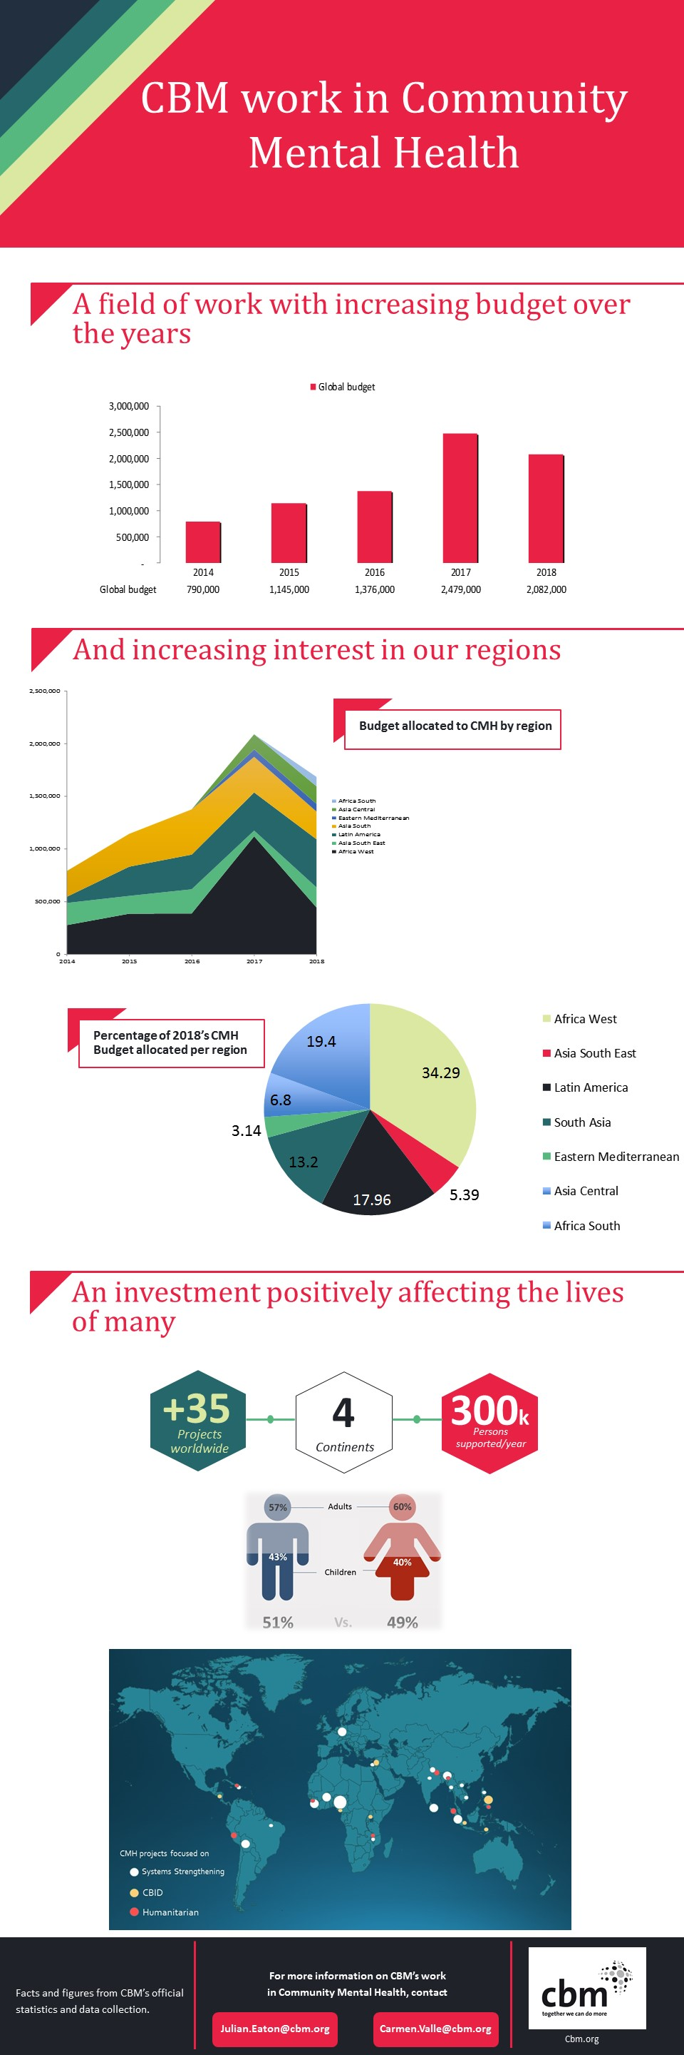

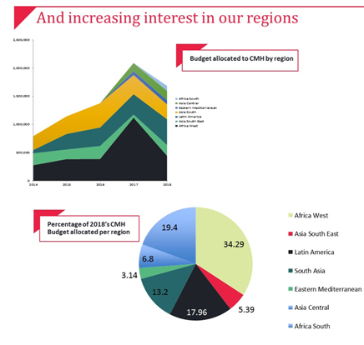At a global level, CBM has been able to influence the discourse of the emerging field of Global Mental Health, and to participate in the development of a stronger movement of people with lived experience, including those coming from poorer countries where CBM works, who have previously been under-represented.

During this time there have been challenges of identifying strong local partners in what is a new field, and where DPOs do not exist in many countries. There has also been a very varied level of interest in different CBM regional and country offices, resulting in an imbalanced portfolio of work globally. The main challenge though, has been the inability of the small number of advisors to provide sufficient response to the many demands during what is a rapid period of growth for the field.

In 2017, BasicNeeds, a well-known and respected NGO working in the field of mental health and development, joined CBM UK. This has quickly increased the expertise available to the Initiative, and potential future programmes. At present, BN works in 16 countries, with a significant overlap with CBM Core and Specific Intervention countries. There is currently a process of integration into CBM under way where most BN partners are expected transition to become CBM partners, and shifting to CBM Country Office support for programmes. Some (eg China, USA) will not be able to do this and other arrangements for sustainability of those local entities will be made. Other elements of BN such as their brand, model of work, and information systems may be a significant asset for the Initiative.

## **4. Context analysis**

Policy Framework

Internal

CBM now has a clear Federation Strategy which provides guiding principles and aids in framing the Initiative. In addition, the Disability Inclusive Development quality standards, gender and protection policies and other elements of the Programme Quality Framework allowed us to position the CMH Initiative within a strong development and rights-based approach aligned to CBM’s vision. Past CMH work in CBM has produced a number of resources that can be drawn upon to guide future work, such as the Reference Guide, Implementation Guidelines, and various other documents. These will be updated to incorporate the Initiative, and some new documents will be developed, such as a Position Paper.

External

CBM works within the framework of the SDGs as well as the CRPD. These provide a clear focus for the work. The SDGs include on major goal (Goal 3) on health and wellbeing, but mental health is also directly relevant to achieving many of the other 17 goals.

Three specific targets relate to mental health directly. These are:

* **3.4:**By 2030, reduce by one third premature mortality from non-communicable diseases through **prevention and treatment and promote mental health and well-being**
* **3.5:** Strengthen the **prevention and treatment of substance abuse**, including narcotic drug abuse and harmful use of alcohol
* **3.8:**Achieve **universal health coverage**, including financial risk protection, access to quality essential health-care services and access to safe, effective, quality and affordable essential medicines and vaccines for all

The earlier Millennium Development Goals made no mention of mental health but inclusion in the SDGs along with the strong commitment to “leave no one behind” means that mental health is starting to get greater prominence.

In addition to these overarching frameworks, there have been a number of other developments, such as the WHO Mental Health Action Plan 2013-2020[1], which all governments signed up to at the World Health Assembly, and which has now been formally extended. This provides a helpful structure of priorities for governments and civil society to follow, with clear targets and indicators. A strong voice of people with psychosocial disabilities, and a human rights framework are overarching principles of the Action Plan. Finally, the Convention on the Rights of Persons with Disabilities provides powerful guidance for inclusion of people with psychosocial disabilities in development.

Terminology and conceptual models linking mental health and disability

Terminology linked to people with mental health problems has historically been extremely negative and often insulting. Part of transforming the world to be more inclusive is to address this language. The CRPD explicitly included disabilities associated with mental health problems, making a dramatic impact on the way that people with psychosocial disabilities started to be seen as an integral part of the wider inclusion agenda and disability movement. CRPD states that:

*"Persons with disabilities include those who have long-term physical, mental, intellectual or sensory impairments which in interaction with various barriers may hinder their full and effective participation in society on an equal basis with others."*

A range of terms are used to describe the spectrum of mental health issues that an individual may experience. It is sometimes more appropriate to use other specific terms, for example ‘distress’ in humanitarian emergencies, or where diagnosis is important for treatment protocols in health services. When we talk about *mental health*, we are referring to a *positive* state of wellbeing, as this field of work is as much about promoting good personal and community wellbeing, as responding to ill health or disability. Diversity and inclusion are essential components of a healthy society.

We recognise that individuals define their own recovery, and that reduction of symptoms may not be the most important contribution to improved quality of life, but social inclusion, positive relationships and other social factors are often identified by people as the most important contributors to their wellbeing.

We use a life-course approach in considering the different needs that different groups may have at different stages of life. While early interventions may focus on maternal and family care, bonding and support, adolescent programmes may focus on managing transition into adulthood and access to education, adult work may focus on employment and relationships, and those in later life may focus on cognitive decline. Some factors such as social networks and exercise are relevant throughout the life course.

The Global Mental Health Sector

A key sector relevant to psychosocial disability is the emerging field of Global Mental Health. Developed over the last 15-20 years, its initial focus was on equitable access to care (reducing the huge treatment gap, especially in lower resourced settings). Addressing the dreadful abuse of human rights common in communities and institutions, for example chaining or ignoring right to self-determination, has also been a string theme in the field. More recently, there has been an emphasis on recognising and addressing social determinants of mental ill health, and promoting population (mental) wellbeing. This implied working across all sectors, at all stages of the life course, especially during early life. There has been a gradual development of concepts, emphasising the impact of environments that are stigmatising and exclusionary, and how these can result in greater disability. However, there is still a long way to go in terms of people with psychosocial disabilities and their representative organisations having a meaningful say in their own destiny. Some recent developments such as the Global Mental Health Peer Network[2] and participation in the Lancet Commission for Global Mental Health and Sustainable Development[3] demonstrate an improving level of participation. CBM has facilitated several discussions about the implications of CRPD on mental health legislation and practice.

## **5. Participation in the Initiative development**

In order to ensure as much participation in the Initiative planning as possible, a range of consultation mechanisms were used. A comprehensive survey was sent out to around 250 stakeholders (CBM Member Associations, CBM Country Offices, CBM International Office, Partners, Disabled Persons’ Organisations, respected experts in the field). In addition to this, field consultations were carried out with a variety of stakeholders on all continents where we work. The data collected from these consultation methods was analysed with the themes emerging being shared at an initiative development workshop held on 15-17th May 2018, at CBM’s International headquarters in Bensheim, Germany.

Consensus was agreed that the following areas should be the priority areas:

1. Service delivery (provision of community level services, including peer-led services)
2. System strengthening (training of health professionals, development of government services, advocacy for mental health funding)
3. Service user voice (supporting DPOs, promoting and supporting service user advocacy)

These themes are in keeping with CBM’s current CMH work and do not represent a major departure from the current portfolio of programming, but are an important endorsement of our approach.

It was widely acknowledged that the advisory structure was a major strength of CBM’s work, but that it needed to be expanded and strengthened to meet increased demands for technical support in the 3-way collaboration approach, and the need to demonstrate high quality in institutional bids.

Feedback, particularly from MA’s, focused on fundraising for mental health. There was wide commitment and interest in exploring mental health as a fundraising cause, and a recognition that fund availability may grow in future, but we need to explore how to engage with donors on the topic.

## **6. Underpinning principles**

CBM’s Approach and Focus

**CBM’s vision**: An inclusive world in which all persons with disabilities enjoy their human rights and achieve their full potential.

The main focus of CBM’s work with people with psychosocial disabilities is to try to strengthen their voice at all levels of society, which we believe will strengthen their ability to advocate for what they need. We also believe that working with communities to raise awareness and reduce stigma will help to break down the barriers that often face people with psychosocial disabilities and that prevent them from contributing fully to society. Through this work, and by demonstrating what is possible, we can persuade governments to strengthen policy, improve legislation and invest in the provision of mental health and social care services to address the gaps in access to the range of supports that promote inclusion and wellbeing.

Justice, Equality and Inclusion

CBM is committed to equality, justice and inclusion. We seek to design our programmes based on levels of need, taking into account needs of marginalised groups. Within the CMH Initiative this includes ensuring that we work across the life-course with regard to the different approaches needed at different stages of life.

We are mindful of the gender differences that both influence who develops mental health conditions, the social consequences, and access to care. In addition, we recognise that women offer the bulk of care to those who have disabilities, affecting their own lives. We will ensure that all our publications and other communications are accessible.

Accountability to persons with disabilities, and to donors

CBM is committed to being fully accountable to persons with disability, their families and representative organisations in all areas of our work. We will put in place mechanisms to facilitate this in practical ways.

We also recognise the need for transparency and accountability in the stewardship of the resources entrusted to us to achieve our aims. Our finance, programme and people management will seek to make our work as efficient and impactful as possible.

Advocacy

CBM is committed to ensuring that our advocacy is embedded across our programme work and is consistent with our mission, grounded in our work, and based on evidence. We are committed to the global principle of “nothing about us, without us”, working to ensure that people with psychosocial disabilities are at the heart of our advocacy efforts.

Sustainability and environmental responsibility

Our main contribution as an international organisation is to sustained and locally owned change that does not rely on our permanent contribution. We will consider local ownership and means of promoting sustainable financing and capacity in our work.

We are aware that the impacts of climate change are borne excessively by marginalised and vulnerable groups, for this reason we are committed to working in an environmentally responsible manner.

Evidence Based Work and technical quality

CBM is committed to ensuring that all our work is grounded in evidence based practice to avoid harm and ensure maximum impact for investment. We also build the evidence base for what works when implementing and share our learning. We believe this approach is the most effective, best practice and strategic way to use our resources. Our Initiative is structured so as to facilitate access to good technical advice at all levels.

Modelling

CBM is committed to ensuring that the way we work values the importance of maintaining good mental health and wellbeing. We seek to model this in our work at all levels in the way that we relate to partners, funders and people we engage with in the countries where we work. CBM’s efforts to foster inclusive and healthy workplaces, and to support wellbeing of staff, is an expression of this.

**WHAT**

## **7. CMH Initiative Priorities**

**Our Initiative Aim**: To promote and improve quality of life of people with psychosocial disabilities through meaningful participation and expanded choices to available care and support services.

Our contribution is to facilitate lasting change at country level using evidence-based and rights-based approaches through our partnerships in countries where we work.

The Community Mental Health Initiative has identified four priorities, they are set out below along with the objectives, indicators, targets and actions that relate to them. These priorities follow the Strategic Goals of the CBM Federation Strategy; Individual, Community, Systems and Other Sectors (including humanitarian response).

**Initiative Priority I: Strong voice of people with psychosocial disabilities**

People with psychosocial disabilities and their representative organisations have a strong voice to influence decisions that affect them.

This Priority forms the foundation of all our work, which should model the inclusive approach that this Priority represents.[4]

| **Initiative objectives** | **Indicators** | **Targets by 2023** |
| --- | --- | --- |
| 1.a. Follow a rights- and evidence-based approach that widens access to peer support  1.b. National presence of representative organisations for people with psychosocial disabilities as well as increased inclusion in the wider disability movement  1.c. Inclusion of psychosocial disability in accountability mechanisms, including CRPD processes | 1.a. Increased number of people using peer support or self-help groups  1.b. Increased number of DPOs representing people with psychosocial disabilities – either new DPOs or existing DPOs widening their representation  1.c. National accountability mechanisms for human rights include consideration of psychosocial disability | 1.a. 50% of CBM programmes with mental health element have peer support component  1.b. 50% of national DPO Federations in Initiative priority countries represent people with psychosocial disabilities  1.c. Engagement in national accountability mechanisms is included in all programmes in CBM core countries |

**Initiative Priority 2: Community inclusion and participation**

People with mental health conditions and psychosocial disabilities live and participate in community life and their contribution is valued in an equal way to others

| **Initiative objectives** | **Indicators** | **Targets by 2023** |
| --- | --- | --- |
| 2.a. Greater community, family and carer awareness of mental health issues, and reduced stigma and discrimination  2.b. More people with a psychosocial disability included in mainstream Community Based Inclusive Development (CBID) programmes  2.c. Increased community engagement around mental health, including through Community Forums | 2.a. Carers, family and community feel better informed and supported in relation to people with mental health conditions  2.b. CBID programmes include more people with psychosocial disabilities  2.c. Community leaders, elders and traditional healers facilitate inclusion of people with psychosocial disabilities | 2.a. Carers, family and communities demonstrates increased awareness and reduced stigma (measured using samples in our programmes)  2.b. More than 50% of all CBM-linked CBID programmes include mental health  2.c. Identify, and test indicator for community participation |

**Initiative Priority 3: Strong, accessible and person-centred systems**

People with mental health conditions are served by systems that are person centred and uphold their rights, including the right to access health and other services. We support greater access to rights through all systems – health, social, education and others – that can either inhibit or support people with psychosocial disabilities.

| **Initiative objectives** | **Indicators** | **Targets by 2023** |
| --- | --- | --- |
| 3.a. Support processes of decentralisation and deinstitutionalisation to make quality services and support available as locally as possible  3.b. Engage in global and national campaigns to close the treatment gap for mental ill health in low resource settings  3.c. Governments where we work have good policies and are influenced to invest in good quality mental health and social services and support | 3.a. Integrated mental health services that respect individual choice and quality  3.b. CBM is part of major global initiatives for inclusion of MH in UHC, NCDs and increased funding for MH  3.c. Other national sectors (such as education, environmental service) respond to the needs of people with mental health conditions | 3.a. Double mental health coverage through services in districts where we work  3.b. 3 examples where CBM is a co-signatory or partner in a global or national campaign  3.c. National mental health budgets move to parity with health in 50% of Initiative priority countries |

**Initiative Priority 4: Mental health is mainstreamed across sectors**

People’s mental health needs are recognised as an integral part of other areas of development, and they have their needs met through other sectors.

| **Initiative objectives** | **Indicators** | **Targets by 2023** |
| --- | --- | --- |
| 4.a. Work closely with CBM Humanitarian Initiative to ensure coordinated support for people with mental health consequences in humanitarian situations  4.b. Collaborate with colleagues in Neglected Tropical Diseases to ensure mental health needs are included in their programmes and priorities  4.c. Work with other initiative areas as opportunities present to integrate MH in their work | 4.a. Increased numbers of people whose mental health is affected by disaster have access to appropriate support  4.b. Increased number of NTD programmes consider the mental health and psychosocial support needs of the people affected by their programmes  4.c. Increased demand for CBM’s expertise in relation to mental health in the fields of humanitarian response, NTDs and other areas | 4.a. Documented inclusion of the needs and wishes of people with psychosocial disabilities in 80% of CBM humanitarian programmes  4.b. Documented integration of mental health and stigma work in NTD programmes in 4 sites  4.c. Publication of MH/Stigma and NTD, and MH as a part of inclusive health resources |

**HOW**

## **7. Building an evidence base for piloting, scaling and influencing**

CBM’s work in mental health has always made use of proven methods, in a way that is contextually relevant in the field. The Initiative Priorities and Objectives above form the core of future programmatic work and will be underpinned with ongoing evaluation and research. CBM’s extensive work of over 10 years in CMH has resulted in a number of specific intervention models being developed and refined. These key areas of expertise have the potential to be shared with others, and to be applied to scaled programmes.

In order to achieve our aims of being in a position to scale up our work when resources are available, we will take each of 7 models that relate to a specific intervention, evaluate and refine them, and develop guidelines for their use in the field. Each is based on work that has been carried out by our partners, which were effective in practice, and which we believe can be applied more widely.

The Initiative will aim to have a full suite of interventions in one country in each CBM region by 2023.

*Table 1: Priority intervention packages for further development and scaling*

|  | **Intervention package** | **Description** | **Origin (CBM partner programmes)** | **Evaluation and related evidence base** | **Stage of development of package** |
| --- | --- | --- | --- | --- | --- |
| 1 | Integration of mental health in Community Based Inclusive Development work  *Linked to Initiative Priority 2 and 4* | Integration of MH into cross disability CBID programmes that often do not include mental health and psychosocial disabilities | Multiple sites in Africa, Latin America and Asia. | Research (PhD) evaluation in Ethiopia. Current research at LSHTM based on review of published and grey literature, plus visits to three CBM programmes | To be developed based on findings of evaluation.  Aim is to contribute to next version of CBID Guidelines |
| 2 | Community Forums  *Linked to Initiative Priority 2* | A practical means of ensuring culturally sensitive engagement in communities Respects local value systems, while introducing rights-based approaches and new service options | Enabling Access to Mental Health in Sierra Leone programme | Evaluation carried out in Sierra Leone, and publication due | Now being adapted and piloted in Malawi (started March 2018) |
| 3 | Peer Groups and strengthening DPOs  *Linked to Initiative Priority 1* | Establishing peer groups. As well as their therapeutic role, a platform for economic empowerment and other work, eg new DPOs where they do not exist | Many countries (often with health system strengthening).  DPO support varies in countries depending on local situation | Some general guidance available (including CBM CMH Impl. Guide).  Evaluation of this work required. Should be co-produced with DPOs | Toolkit written (in conjunction with BasicNeeds) following project evaluation in 2012.  Update required. New QR toolkits and experience. |
| 4 | BasicNeeds model of mental health and development  *Linked to Initiative Priority 1 and 2* | Model developed by BasicNeeds in 2003. Used extensively as basis for many programmes | BasicNeeds programmes in Ghana, India, Tanzania, Laos, etc | Several research and evaluations. Started major retrospective evaluation (June 2018) | Updated model to be shared following eval.  Package may link to peer group, and/or CBID work |
| 5 | Anti-Stigma and awareness-raising  *Linked to Initiative Priority 2* | Recognised as a major issue in mental health, but hard to change attitudes. Growing evidence, partly driven by evidence from CBM’s work | Nigeria (Amaudo Itumbauzo), and several programmes based on this. New MOU with Time to Change | 2 publications on Amaudo work.  Significant literature on related stigma and mental health work (including in low income settings) | Current development of model of intervention through King’s College London (INDIGO) using Amaudo work |
| 6 | Mental Health System and service strengthening  *Linked to Initiative Priority 3* | Science underpinning key aim of Global MH to reduce treatment gap and promote rights. Largely based on reform of health service and integrating MH into other sectors | Aceh, Burkina Faso, Niger, Nigeria (several) | Several publications on CBM partner work (mhLAP, mhSUN)  Significant literature on related services work in low income settings | mhSUN will result in package to complement already very strong resources developed by WHO – mhGAP and complementary QualityRights resources |
| 7 | Mental Wellbeing and Stigma in Neglected Tropical Diseases (NTDs)  *Linked to Initiative Priority 4* | Linking mental health and NTDs, CBM and partner NGOs are working to improve mental health support for people affected by NTDs, and address community stigma | Prevalence and qualitative studies published in Jos, Nigeria. | Systematic review to understand links between MH, stigma and NTDs. Will result in theory and basis of intervention. | Package being developed now with NNN and WHO.  Subsequent work in Ethiopia, Nigeria, DR Congo planned |

## **8. Priority countries**

We will prioritise certain countries in order to focus attention towards growing our number of programmes, while ensuring sufficient attention is paid to existing programmes to assure high quality implementation.

The considerations in identifying relevant countries are:

* Countries that already have strong programmes, building on our current portfolio as this is important for national advocacy for sustained change
* Countries which have included mental health as a priority in their Country Plans
* Countries whose country and regional office staff have expressed interest in mental health and have demonstrated capacity in support of programmes
* Countries that have support from MAs who wish to further develop community mental health work (Australia, Germany, Swiss, Italy, UK)
* Countries where there are strong partners who can deliver mental health programmes, including those with BasicNeeds partners
* Achieving an even spread across regions and a balance in countries within regions where practical

Ultimately we aim to see community mental health as a part of the comprehensive work of CBM in most core countries. CMH will continue to be the main type of work in some specific intervention countries.

In addition, it is clear that global mental health funding in future may be of a regional and multi-country nature. It is important that the CMH Initiative is able to work within an environment in CBM’s 3-way collaboration that is sufficiently flexible to support ambitious funding applications for innovative programmes.

*Table 2: Country prioritisation logic, leading to CMH Initiative priority countries*

| **Core and SICs Countries** | **Core, SIC, or phase out** | **Priority for CMH, little inclusion, not included**  **in Country planning** | **MA Support for MH** | **BN Partner**  **Active, inactive/historic, none** (blank) | **Notes** | **Priority**  **10 priority countries (PC)**  **10 2nd tier (ST)** |
| --- | --- | --- | --- | --- | --- | --- |
| Africa |  |  |  |  |  |  |
| Benin |  |  |  |  |  |  |
| Burkina Faso |  | Approved | Swiss |  |  | PC |
| Burundi |  |  |  |  |  |  |
| Cameroon |  |  | Germany |  |  | ST |
| Central African Rep. |  |  |  |  | ? MH/NTD work |  |
| Côte d’Ivoire |  |  |  |  |  |  |
| Congo DR |  | Planned for 2019 |  |  | NTD/MH work |  |
| Ethiopia |  | Approved | Italy (NTD/ CBID) |  | CBID, NTD/MH work | ST |
| Ghana |  |  |  |  | Large BN programme, plus CBID | Link to BN and ongoing projects |
| Guinea C |  |  |  |  |  |  |
| Kenya |  | Approved |  |  | Gov buy-in | PC |
| Madagascar |  | 2019 |  |  | Interest shown | ST |
| Malawi |  |  | UK |  | New programmes | PC |
| Niger |  | Approved | Australia |  |  | PC |
| Nigeria |  | Ongoing | Australia |  |  | PC |
| Rwanda |  | Approved |  |  |  |  |
| Sierra Leone |  |  | GermanyUK |  | Strong MH programmes | PC |
| South Africa |  |  |  |  |  |  |
| South Sudan |  |  |  |  | Much need and potential partners |  |
| Tanzania |  | Start May 2018 |  | Past work |  |  |
| Togo |  | Approved |  |  |  |  |
| Uganda |  |  |  | Via Network for Africa |  |  |
| Zambia |  |  |  |  |  |  |
| Zimbabwe |  | Approved |  | Via Health Poverty Action |  |  |
| Asia/EMRO |  |  |  |  |  |  |
| Bangladesh |  | Approved | Germany |  | Strong MHPSS/CBID | ST |
| India |  | Approved |  |  | Interest in CMH/CBID | ST |
| Indonesia |  | Approved | GermanyAustralia |  |  | PC |
| Lao PDR | Could be core | About to be approved | Swiss |  | CBID and BN | ST |
| Myanmar |  |  |  |  |  |  |
| Nepal |  | Approved | UK |  | Campaign | PC |
| Pakistan |  | Approved | Swiss |  |  | ST |
| Philippines |  | Approved | Germany |  | CBID | PC |
| Sri Lanka |  |  |  |  |  |  |
| Thailand |  |  | Australia |  | CBID QR |  |
| Viet Nam | Changed to SIC | Approved | Australia |  | Proposal written |  |
| Yemen |  |  |  |  | Only MHPSS |  |
| Latin America |  |  |  |  |  |  |
| Bolivia |  | Approved | Italy |  |  | PC |
| Guatemala |  | Approved |  |  |  | ST |
| Haiti |  | Approved |  |  |  | ST |
| Honduras |  |  |  |  | EU grant MH component |  |
| Nicaragua |  |  |  |  | Integrated in CBID |  |
| Paraguay |  |  |  |  | Mainstream in eye care |  |

## **9. Human Resources and structures**

A key purpose of the Initiative is to provide support to partners, and assure quality in our programmes. In order to do this; capable people, sufficiently resourced to work effectively, in the right places, are the cornerstone of our work. We believe in decentralisation of advisory availability to country level, reflecting our principles of local empowerment, and recognising the contextual knowledge of local advisors. Advisors may be CBM staff, partner personnel, or local experts in government or civil society. At the same time, CBM has emphasised the need to raise its international profile and impact by providing for high level representation of CBM on global forums.

*Figure 3: Human resource needs and proposed structure for CMH Initiative*

*(Red border indicates line managed by CMH Initiative, blue border by Country Office)*

Countries with mental health work will designate an advisor. This person might be full or part time based on the volume of work.   
Core countries will have a CMH focal person.

1 Initiative Director

1 Global Initiative Manager

*Based in strategic location for role (may or may not be field country)*

(Core Initiative Team (ID, GA and RAs))

1 Regional Advisor per region (4 total)*.

*Based in region (eg busiest country). May have specific country or programme responsibility, or contribute part of their time to global advisory work*

**The Initiative Director** will be the senior technical, as well as strategic lead for the Initiative, able to provide high level input into CBM resources, supervision of advisors (direct for Regional Advisors), and representation of CBM at relevant forums at the highest level.

**Other global advisors** in specific areas (eg psychosocial interventions, humanitarian response, etc) may be appointed full-time, or work part-time in this role, and part-time as Regional Advisors.

**Regional Mental Health Advisors** (with some global responsibilities) form part of a strong and coherent global team (a Core Initiative Team), line managed within the Initiative. There will be a Regional Advisor for each (new) Region, mainly based in the field (in Regional Hubs, Country Offices or partner projects). These senior advisors may have a part of their time dedicated to global work.

**National Advisors** (only in Initiative priority countries with significant work)and **CO focal points for community mental health** (in all other core countries) will be line managed within the Country Office, but will be more closely linked to the Initiative by having a clear relationship and support from the Regional Advisor. They will be based in Country Offices, partners, or be local independent experts. In many cases, they will be a Regional Advisor. They will belong to the Community of Practice, and be taken through the CBM Advisor training covering our perspective on CMH, and inclusive development.

Large, exceptional, and inter-regional programmes will be run more directly by the Initiative, sometimes in partnership with a specific MA. If the number of these grow, we will need to consider an office base and admin/finance staff at a future date. Prior to that it is not envisaged that there will be a clear geographical site for the Initiative staff.

## **10. Financial Resourcing**

The New World – growing interest and funding for mental health

Historically, support for work in global mental health has been limited. Only a few multi-lateral donors have funded mental health work, few bilateral donors have given much and individual support for international work in mental health has not been tested. As a result, less than 1% of global expenditure on health in LMICs is spent on mental health although global burden of mental illness accounts for 32-34%[5] of all years lived with disability. This disparity between need and investment has been a major advocacy point, which is starting to have an impact.

*Graph 1&2: From historically low levels of Development Assistance for Mental Health, there has been a 10-fold increase in the last 20 years, a trend which is accelerating[6]*

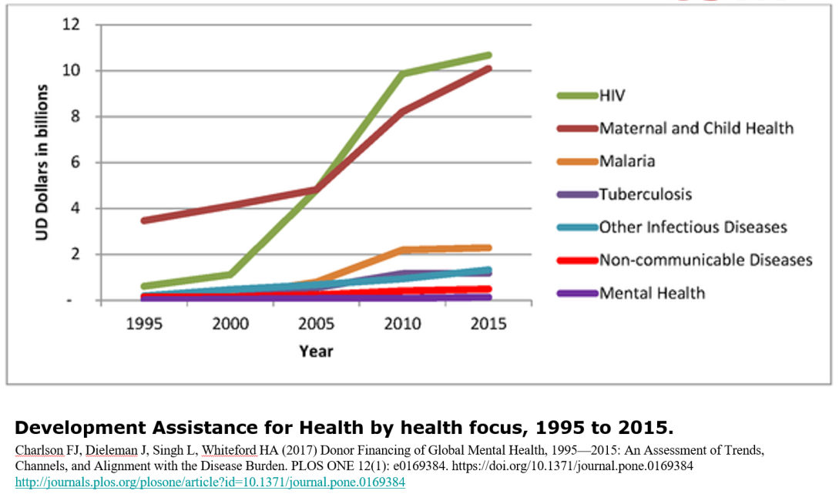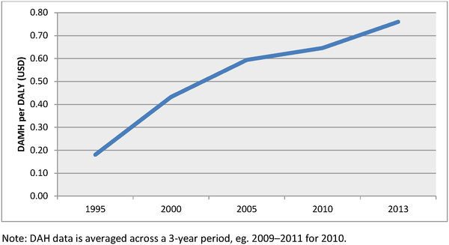

In 2016, the World Bank and WHO co-hosted a meeting examining global mental health financing, following which this has been a topic in several WEF Davos meetings, and high level discussions at the United Nations. There are a number of initiatives that make this an opportune time to be investing in global mental health.

*The Blue Print Group* aims to strengthen the funding mechanisms for people with mental health conditions, and is coordinating a series of events around the Global Mental Health Summit in London, World Mental Health Day and the World Economic Forum in Davos. This is likely to bring about significant increases in financing for mental health, while enabling a more cohesive common messaging and effective advocacy. They partnered with the *Lancet* and the *Mental Health Innovation Network* for the launch of the Lancet Commission on Global Mental Health and Sustainable Development. CBM has close collaboration with all these processes.

Outside of health, there is increasing recognition of psychosocial disability within inclusive development circles, with UK *Department for International Development (DFID), Australia’s DFAT, the Open Society Foundation*, and other funders clearly scaling up this work. Research funders are significantly scaling up research funding.

*The World Network of Users and Survivors of Psychiatry (WNUSP)* is a founder member of the International Disability Alliance, and has been prominent in ensuring that debates around implementation of the UN CRPD include consideration of psychosocial disability. Regional networks such as the *Pan African Network of Persons with Psychosocial Disabilities* and *TCI-Asia Pacific* now support growth of national movements with strong regional leadership.

*The Global Anti-Stigma Alliance* was founded in 2012 to bring together a number of national anti-stigma groups, share learning and achieve better outcomes for people facing stigma as a result of their mental health issues. In 2018 the UK based Time to Change campaign secured funding from the UK government to pilot in LMICs within the Commonwealth. This work has a strong ethos of evaluation, and likely to be the first of many investments in this area. CBM has established a partnership with *Time to Change Global* to deliver anti-stigma work in 5 countries.

Positioning CBM to be a proven partner in delivery of scaled interventions for change

As very few INGOs are committed to significant work in mental health in the world’s poorest regions, CBM has already earned itself a strong position in the past ten years. The merger of CBM UK with BasicNeeds in 2017, an organisation with twenty years of expertise in CMH, reinforces this. Being well connected to the international network of associations and institutions engaged in GMH issues, means that CBM already has the trust of many potential donors. This Initiative plan seeks to position CBM as the foremost organisation with the capacity and reputation to implement substantial mental health work in low income countries.

Direct Fundraising for mental health

CBM does not have a history of fundraising directly from private donors for community mental health work. While the use of general donations for mental health demonstrates a commitment and vision, it is important to raise funds specifically for CMH.

Including mental health transparently in our fundraising will show our expertise, and emphasise our leadership as other organisations explore this area of work. This is an opportunity also to educate the public and provide thought leadership around psychosocial disability, stigma and exclusion.

Institutional Fundraising

There are many international bilateral, multilateral and private organisations that have started to move beyond acknowledging the importance of mental health, to actively establish structures for funding into this space – in part because of the SDGs and CRPD, but also because of improved advocacy by the mental health community.

CBM has an established history of working with corporate donors. Mental health is an area which is gaining significant traction with corporate entities, and is an area that the Initiative can support CBM to realise.

Basic fundraising messages and CBM’s capacity to offer solutions:

**Relevant, current and urgent challenge:** CMH programmes address serious problems that cause suffering for individuals and their families. This is still largely unknown, and CBM has a long track of engaging in this issue.

**Understandable and feasible solutions offered by organisation:** Through access to comprehensive treatment, peer support, anti-stigma campaigning, educational and advocacy activities in rural traditional societies, people with psychosocial disabilities can live better lives in dignity, freedom and social participation.

**Impactful and indispensable contribution by donors/institutions:** Due to the very high quantity of people in need in many poor countries, their governments cannot solve the problem alone in the near future. This addresses individuals, as well as institutions and companies, as mental conditions can affect everybody and help can be delivered.

**Communicable and emotionally tangible impact of donor support:** Both images and individual stories can serve this aim if beneficiaries, partners, advisors, COs and MAs work together to prove that transformation can be realized.

## **11. Quality Assurance. Monitoring, Evaluation and Learning**

The CMH Initiative will seek to not only substantially scale up the work we do in CMH, but also to ensure that it can be demonstrated to be of the highest quality, and can be shared with others.

Quality assurance

This is one of the core functions of the advisory structure that we are proposing, through support of programme development, clear benchmarking of standards expected, investment in training and mentoring local advisors, and availability for technical advice.

Monitoring and Evaluation

In general, this will be done by integrating Initiative needs into the standard procedures for routine data collection and collation, for example through the Project Progress Reports, and analysis of statistics. We routinely carry out internal mid-term and independent external final evaluations of all programmes.

In addition to this routine M&E, specific indicators are used as appropriate. These are often based on the CMH Reference Guide and linked to national and global standard indicators (like the WHO Mental Health Action Plan), and may feed into national information systems, as in health system strengthening programmes. CBM also carries out some more in-depth evaluations of identified programmes. For example, we are currently carrying out a global evaluation of integration of mental health into our CBID work.

In the case of very large, inter-regional or otherwise unique projects, the Initiative will have the flexibility to manage them more directly where this is necessary, though this will be the exception, and only possible where the associated costs are included in the project budget, for example with larger institutional funding.

Learning and research

Lessons learnt from evaluations must be used to continually improve programmes, to help partners to strengthen their implementation, and to share with the wider Initiative to allow dissemination of improved practice. The Community of Practice is a natural platform for this, either by sharing written materials or in the regular webinars.

CBM has a strong track record of publishing research carried out in partner programmes. With the proposed focus on evaluating and publishing results from key interventions, this will be structured in a formal way so that we will have string proof of concept and outcome data to improve the quality of our work, and strength proposals.

## **12. Internal and external communication**

We will maximise the impact of our work by establishing means of communicating effectively between CMH actors in CBM, and sharing widely through existing CBM communication channels and external platforms.

In addition to the **Core Initiative Team**, our communications will be built around:

* **A community of practice (COP)** – comprised of people working in the CMH Initiative team and those with technical knowledge and responsibility for programmes based in MAs or Country Offices (Advisors, Focal Points).
* Communications will be based on webinars/GoToMeetings on a bi-annual basis coupled with ongoing communication via email, yammer and other mediums.
* A *fundraising sub-group* will focus on sharing approaches to fundraising in mental health – this will cover restricted and unrestricted fundraising work.
* A *BasicNeeds model/CBID sub-group* will focus on networking partners in community-rooted work, and implementing lessons learned from the BN model and CBID reviews.
* **A community of interest (COI)** – which will be the above plus those with an interest in mental health whether because they are in an alliance relationship, fundraising, involved in programming or in a partner programme.
* Communications will be based on use of email updates highlighting ongoing work, linking to the wider communications below.
* **Internal CBM communications** through existing channels:
* Communications will be based on contributions to the Federation Newsletter, an Initiative intranet page, and presentations in the Federation webinar series
* **External communications** will also focus on existing CBM channels and resources with programmes being supported to develop materials, stories, photographs etc to support CBM’s global media strategies.

## **12. Alliances and advocacy**

In order to achieve our wider objectives, we have worked closely with specific organisations historically, often with significant impact, for example in advocacy for mental health inclusion in the SDGs. As we prepare the Initiative plan, we have reassessed the value of these, and considered new options for alliances that are well aligned to the overarching and specific Initiative objectives. We have taken into consideration which organisations are the most active and influential, in order to focus our energy in the most impactful directions. Actual engagement varies, but consists mainly of time of advisors. Most do not require funds, but we have contributed to WHO for their work in normative materials development.

**Objective 1: Empowering individuals** *Disabled Persons’ Organisations.* We will work closely with representative organisations of people with psychosocial disabilities; *World Network of Users and Survivors of Psychiatry, Pan-African Network of Persons with Psychosocial Disabilities, TCI Asia Pacific (Transforming Communities for Inclusion of persons with psychosocial disabilities).* We have a formal agreement with the *International Disability Alliance*

**Objective 2: Inclusive communities** *Global Anti-Stigma Alliance*, which is relatively newly formed, but influential, and has a strong ethos of being led by people with lived experience. CBM UK has signed an MOU to explore programme collaborations. We will work at a country level with *Time to Change*, a leader in the Alliance.

**Objective 3: Systems** *World Health Organisation*, long-standing fruitful relationship, producing core normative guidelines (mhGAP and QualityRights) and very influential. Have been increasingly rights-based in their approach.

**Objective 4: Other sectors/humanitarian** *Inter-Agency Standing Committee (IASC) Mental Health and Psychosocial Support (MHPSS) Reference Group,* currently undergoing a process of integrating inclusive approaches. *NTD NGO Network (NNN), Mental Wellbeing and Stigma Task Group*. Established (and currently chaired) by CBM in 2017, is the main convener for MH/NTD work and the focus of work with WHO in this area.

## **13 Conclusion**

The Community Mental Health Initiative will allow CBM to have a great impact on the lives of people with the most common forms of disability, but one that has huge unmet need. We are well placed to build on our past work, and embrace the opportunity of the new interest in mental health as a global development agenda.

Julian Eaton, March 2019

## **Annex 1: Glossary of acronyms**

CBID – Community Based Inclusive Development

CIT – Core Initiative Team

CMH – Community Mental Health (CBM’s term for our mental health work)

COP/I – Community of Practice/Interest

CRPD – UN Convention on the Rights of Persons with Disabilities

DFAT – Department of Foreign Affairs and Trade (Australia)

DFID – Department for International Development (UK)

DPO – Disabled Persons’ Organisation

IASC – Inter-Agency Standing Committee

ILT – International Leadership Team

MA – CBM Member Association

MEL – Monitoring, Evaluation and Learning

MH – Mental Health

MHPSS – Mental Health and Psychosocial Support

NCD – Non-Communicable Diseases

NTD – Neglected Tropical Diseases

RA – Regional Advisor

WHO – World Health Organisation

WNUSP – World Network of Users and Survivors of Psychiatry

1. World Health Organisation. Comprehensive Mental Health Action Plan 2013–2020. WHO, Geneva, 2013
2. <http://www.mhinnovation.net/launch-global-mental-health-peer-network>
3. Patel V, Saxena S, et al. The Lancet Commission on global mental health and sustainable development. Lancet 2018 [www.globalmentalhealthcommission.org](http://www.globalmentalhealthcommission.org)
4. Many elements of this Priority are linked to the work of the CBM Disability Inclusive Development Initiative. This will enable use of shared indicators and use of resources and expertise such as DID Bridge training
5. https://www.thelancet.com/journals/lanpsy/article/PIIS2215-0366(15)00505-2/abstract
6. Charlson FJ, Dieleman J, Singh L, Whiteford HA. Donor Financing of Global Mental Health, 1995—2015: An Assessment of Trends, Channels, and Alignment with the Disease Burden. PLOS ONE 2017. 12(1): e0169384.

   <http://journals.plos.org/plosone/article?id=10.1371/journal.pone.0169384>