Preconditions for   
inclusion overview

An introduction to the why, what and how of the preconditions for inclusion framework to promote   
disability equity and rights.

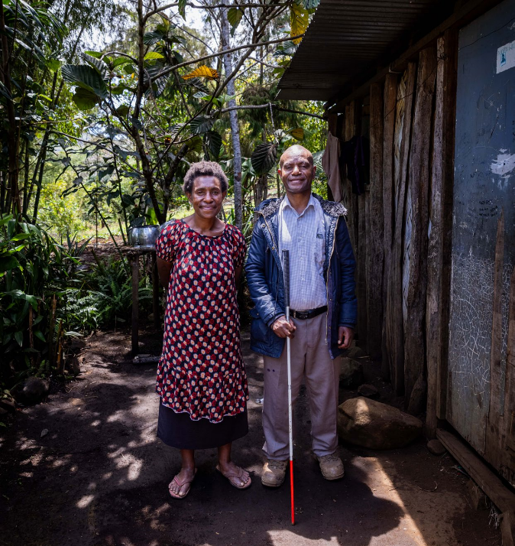

Ben, an assistive technology user, and his wife Louise who often provides personal assistance to also facilitate Ben’s equal participation. Goroka PNG. Photography by Erin Johnson for [Room3.com.au](http://room3.com.au/)

The thinking and conceptualisation in this paper is a result of the shared learning and experiences of Pacific Disability Forum (PDF) and CBM Inclusion Advisory Group (IAG). We are committed to continuing to amplify the voices and priorities of persons with disabilities to enable their progress towards full realisation of equity and rights within their cultures and contexts.

Table of Contents

Overview 3

1. Why are the preconditions for inclusion important? 4

2. What are the preconditions for inclusion? 5

2.1 Key common elements 6

2.2 An interlinked framework 12

2.3 Addressing structural gaps 14

2.4 Working together with general development efforts 15

3. How can the preconditions be applied in practice? 16

3.1 Preconditions analysis 16

3.2 Through precondition efforts 19

3.2.1 Dedicated precondition efforts – from the start 19

3.2.2 Preconditions efforts – opportunities identified ‘as you go’ 20

4. Additional approaches and resources 24

4.1 CBM Global’s approach to preconditions 25

4.2 Pacific Disability Forum’s approach to preconditions 26

4.3 Further resources and other organisations’ approaches 27

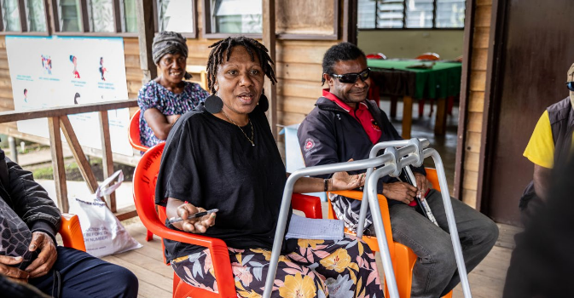

Nelsie (centre) works with local OPDs in Papua New Guinea to advocate for accessible, affordable and appropriate assistive technology for people with disabilities in her community. Photography by [Room3. com.au](http://room3.com.au/)

# Overview

The preconditions for inclusion are a **framework of key elements that need to be in place in society in order to build an enabling environment for inclusion and equity for people with disabilities.** When these elements are not in place, there are likely to be significant and persistent structural barriers that prevent people with disabilities from participating in programs, services, opportunities and everyday life in their communities on an equal basis with others. **This will occur even when programs and services have strong disability inclusion practices.**

To achieve equity and rights for people with disabilities, the preconditions must therefore be prioritised and implemented, alongside continuing inclusive development efforts. Stakeholders are increasingly adopting a preconditions framework, in recognition that **without systemic efforts to address gaps in the preconditions, people with disabilities will continue to be excluded from their services and programs**. Practically, the preconditions framework can guide research and analysis and inform the design and direction of policies and programs.

This brief aims to provide an **overview** of **why** the preconditions framework is crucial to disability equity, **what** the preconditions framework involves, as well as outlining **CBM Global, PDF** and others’ versions of the preconditions framework and **how** these work together.

# Why are the preconditions for inclusion important?

Structural gaps and contextual barriers prevent people with disabilities from participating in even the most inclusive programs

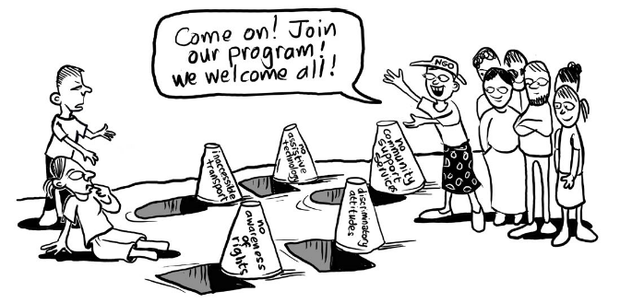

Image credit Julie Smith/CBM

Over the past decades, the development and humanitarian sectors have **increasingly recognised the importance of including people with disabilities,** particularly through disability-inclusive mainstreaming practices, as well as supporting Organisations of Persons with Disabilities (OPDs). These efforts have led to excellent progress towards disability inclusion, building more inclusive programs and services and improving the lives of people with disabilities, and must be continued.

At the same time, people with disabilities highlight that disability-inclusive practices within programs, services and policies **are often not enough for their full participation.** This is because **they live in communities and contexts where there are persistent structural barriers to their inclusion.**

This means that **even if a program or service has applied robust disability inclusion practices** within its own processes, people with disabilities will not be able to access it because of **structural gaps within the broader context or environment outside that program or service.** Such structural gaps may include:

* Inaccessible buildings and infrastructure such as footpaths, transport, information or communication
* Discriminatory and prejudicial attitudes and norms throughout various parts of society
* No awareness that they have equal rights to opportunities or services, and the right to reasonable accommodations
* No access to assistive technology or support services to enable people with disabilities to move around, communicate or otherwise participate with independence, ease and/or dignity
* Lack of legal protections against discrimination on the basis of disability, and/or lack of legal pathways to complain or seek redress for discrimination.

The preconditions for inclusion systemically address these gaps to create an enabling environment for inclusion

The preconditions for inclusion are a **framework of key elements that need to be systemically addressed at national, sub-national and community levels in order to address these structural gaps and contextual barriers.** Doing so will ensure that people with disabilities can participate in programs, services, opportunities and everyday life in their communities on an equal basis with others.

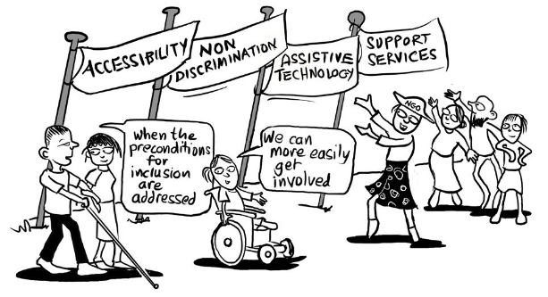

Image credit Julie Smith/CBM

# What are the preconditions for inclusion?

Overall, the preconditions for inclusion are a policy framework. This framework is made up of essential and interlinked elements.

Globally to date, several organisations have developed their conceptualisation of the preconditions for inclusion framework (see Further Resources). While each of these differ slightly depending on the organisations’ own context and purpose for developing their version, **all versions so far can be seen to be** **complementary** **and so far all cover four common elements:**

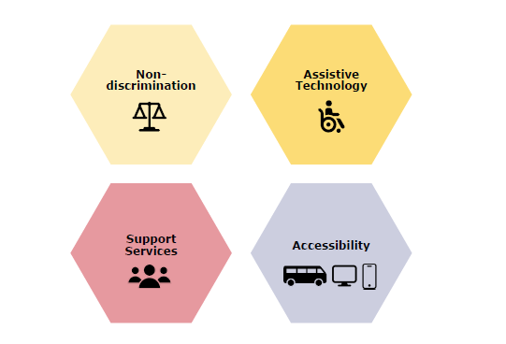

These four components are also strongly emphasised as General Obligations under Article 4 of the United Nations Convention on the Rights of Persons with Disabilities (UNCRPD), and framed in the Special Rapporteur on the Rights of Persons with Disabilities’ [Report on Disability-Inclusive Policies](https://www.ohchr.org/en/documents/thematic-reports/a71314-report-disability-inclusive-policies) as being ‘pre-requisites’ to achieving UNCRPD and the Sustainable Development Goals for people with disabilities.

**CBM Global’s approach** to the preconditions involves these four core preconditions, and then four further additional elements: **recognising the extra costs of disability, community inclusion, inclusive data and budgeting, and participation and empowerment.**

**PDF’s approach** to the preconditions involve six preconditions: the four common preconditions outlined above plus **social protection and community-based inclusive development.** These will be outlined further in Section Four.

This guidance note will now **briefly overview what each of these common four elements entails,** and then discuss **how the preconditions can be understood and applied as a framework.**

## Key common elements

Accessibility (Article 9, UNCRPD)

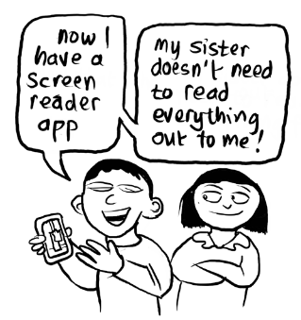

Image credit Julie Smith/CBM

**Accessibility** is taking deliberate actions to ensure **everyone can equally access**:

* Physical environment
* Transport
* Information and communications
* Public facilities and services e.g. shops, cash machines.

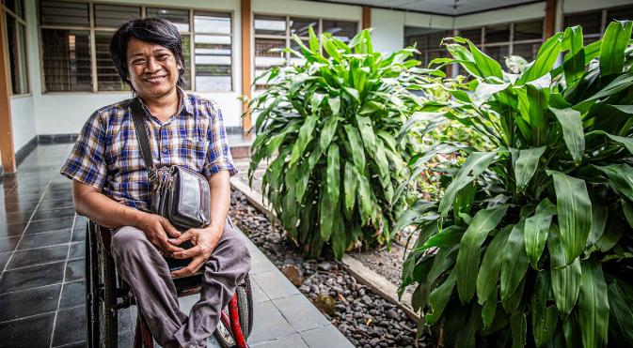

Assistive technology together with an accessible built environment enable Budi (46 year old, Yogyakarta) to live with much greater independence and equity. Photography by Erin Johnson for [Room3.com.au](http://room3.com.au/) ©2023

Assistive technology (Articles 9, 20 and 26, UNCRPD)

* **Assistive products and devices –** such as wheelchairs, white canes, screen readers, hearing aids, walkers, prosthetics, orthotics, Braille display, voice recognition software, etc.
* **Assistive services –** services related to fitting, maintenance, repair of assistive products and devices, as well as infrastructure for training and referral around all assistive technology.

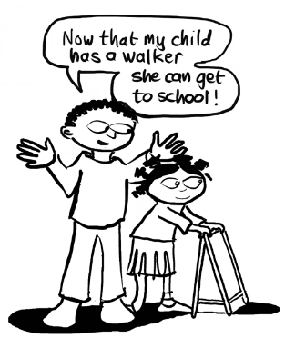

Image credit Julie Smith/CBM

Non-discrimination (Articles 4 and 5, UNCRPD)

Discrimination occurs where there are **norms, practices, policies and laws** that exclude people on the basis of disability – even indirectly. This can include:

* Denying **reasonable accommodations (RAs)** – RAs are actions that individuals need to be able to participate equally in a specific situation (for example, being provided with printed copies of PowerPoint presentation slides before workshops, or an aide for work-travel).
* **Direct discrimination –** expressly treating someone differently or unfairly on the basis of their disability (for example, not allowing a child to enrol in school, or not employing a person because they have a disability).
* **Indirect discrimination –** practices that disproportionately disadvantage people with disabilities (for example, failure to provide accessible voting materials and venues, meaning that people with disabilities cannot access their right to vote).
* Denying **equal legal capacity -** that is, being denied the choice to make decisions about one’s own personal, health care and financial life on the basis of having a disability. This is often experienced by people with psychosocial and cognitive disabilities.
* **Multiple and compounding discrimination –** creating additional and unique disadvantage (for example, experiencing discrimination on basis of being a woman, and/or from an ethnic minority, and having a disability (‘intersectional discrimination’)).

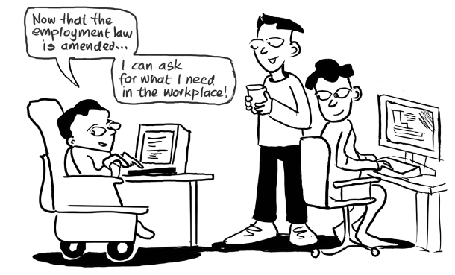

Image credit Julie Smith/CBM

**Non-discrimination** as a precondition therefore covers initiatives to address discriminatory norms, practices, laws and policies. This includes both:

1. **Law and policy reform work** so that these are in place to protect and enforce people with disabilities’ **right to non-discrimination,** including bringing national laws in line with the UNCRPD and passing disability laws and policies. Efforts here also involve **mobilising and taking action to redress** discriminatory practices, such as advocacy campaigns, legal recourse and access to justice.
2. **Efforts to change discriminatory norms and attitudes.** This includes **raising awareness about rights** amongst people with disabilities, as well as amongst their communities, program implementers, governments and other stakeholders to **challenge and reduce negative stereotypes,** beliefs and practices about people with disabilities. Increased rights awareness also empowers people with disabilities to **assert their rights** to equality and non-discrimination.

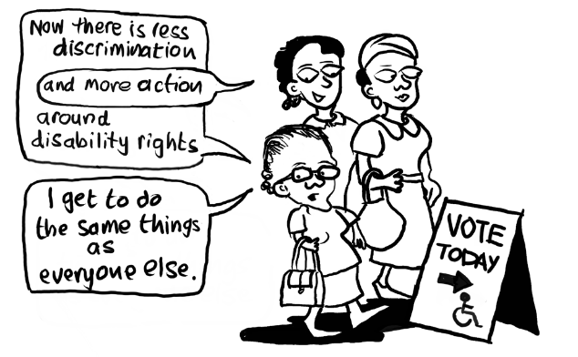

Image credit Julie Smith/CBM

Support services (Articles 5, 12 and 19, UNCRPD)

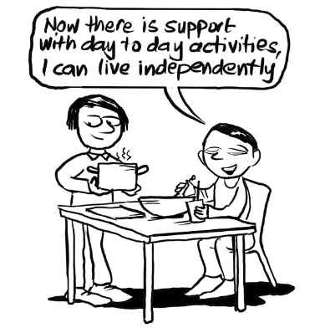

Image credit Julie Smith/CBM

**Support services** is assistance and support required to fully participate in everyday life with dignity and choice. This can include:

* Carers and personal assistance
* Sign language interpreters
* Peer-led models of support
* Supported decision-making
* Other communication support.

Support services are:

* Often particularly critical for some of the **most marginalised people with disabilities,** including those with intellectual and psychosocial disabilities, people with high support needs, elderly people with disabilities, Deaf and Deafblind people, and people with other communication disabilities.
* A key element to taking a disability rights-based approach to addressing the **care agenda** and has a **strong gendered component,** given that informal caring responsibilities are disproportionately borne by women and girls.
* Essential to **deinstitutionalisation** – the gradual process of supporting people with disabilities to live in regular, community-based housing with dignity and choice, rather than in institutions that violate their rights.

It is crucial to develop models of support services that are delivered in the community, culturally appropriate, contextual (for example, considering rural versus urban considerations) and build upon existing support networks and systems within communities.

## An interlinked framework[1]

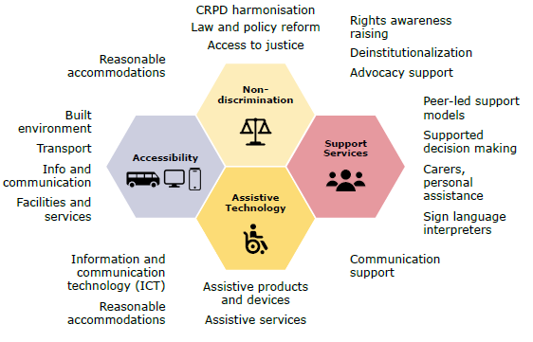

It is important to remember that the preconditions framework is not just a list of components, but an interlinked framework. **While there are discrete components, they work together as a collective framework for inclusion.** If a need under one component is missing, it can create a structural gap in the overall enabling environment. Moreover, **because these components are frequently interlinked and interdependent, gaps in one area will often lead to further structural barriers.** For example:

* **Assistive technology** such as wheelchairs, white canes and screen readers **require accessibility** in built environments, transport and communications to be effective.
* **UNCRPD review of national laws and policies** and/or **introduction of non-discrimination laws** are often essential to **ensure access to reasonable accommodations,** which also frequently require access to **assistive technology or support services.**
* Addressing **discriminatory norms and attitudes** amongst public services staff will link to increased **accessibility** of public services.
* Support services such as sign language interpretation, supported decision making and peer-led support models are all essential to achieve non-discrimination in practice. For example, these supports are essential to support Deaf people or people with psychosocial or intellectual disabilities to become aware of their rights to not be discriminated against and pursue legal redress and advocacy when these rights are violated.
* Social protection and measures to address the extra costs of disability are often required to be able to afford assistive technology and support services.
* **Community inclusion and community-based inclusive development** (CBID) approaches are often key strategies to ensuring people with disabilities are linked into services and programs enabling access to **assistive technology and support services (amongst other outcomes).**
* CBID and strengthening community inclusion is also a core part of addressing discriminatory norms and practices in societies, as is empowerment of people with disabilities. Inclusive budgeting and data, and participation of people with disabilities in decision making are all essential for sound and informed policy making and planning that will appropriately and effectively deliver on all precondition areas.

This means that the preconditions framework calls on us not only to **prioritise the individual preconditions elements** but also to **look broadly to the experiences of people with disabilities in context** and assess where there are structural and systemic gaps that need to be addressed to build the enabling environment for disability equity.

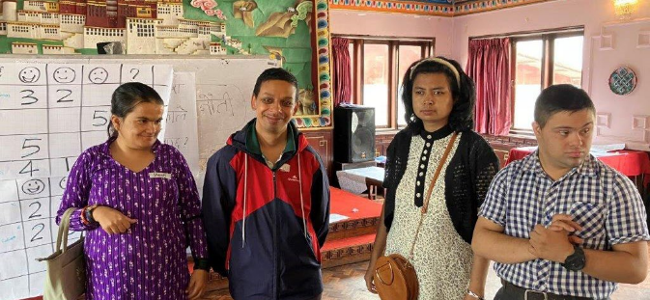

Non-discrimination: People with intellectual disabilities from Nepal presenting what has changed for them through a CBM project that focused on improving disability considerations in government policies and actions.

## Addressing structural gaps

Activities to implement the preconditions for inclusion are focused on achieving long-term, systemic changes to address structural gaps on national, sub-national or community-wide levels.

This is **distinct from disability inclusion practices,** that is, **efforts that make an individual program, service or organisation more disability inclusive.** Disability inclusive practices are very important to improving the lives of people with disabilities and should be implemented by all programs, services and organisations (such as those relating to inclusive health; education; water, sanitation and hygiene (WASH); disaster risk reduction; gender equality, etc). Significant impact has been made through disability inclusion practices in general development efforts in recent years and **it is crucial to continue this investment and momentum.** These types of practices, however, are often limited to individual programs, services or organisations, and **do not systemically address structural gaps and barriers** at national, sub-national, or community-wide levels.

|  |  |
| --- | --- |
| Disability inclusion practices: | Precondition efforts: |
| * Ensure people with disabilities can **participate in an individual program or service** equally. | * Are focused on achieving **long-term, systemic changes to address structural gaps** under the precondition area on **national, sub-national or community-wide** levels. |
| * If all general programs, organisations and services focus their disability efforts only on these, **persistent structural barriers will remain** to disability equity. | * Create a long-term **enabling environment** across society **that facilitates** people with disabilities’ **equal access to general programs, services, opportunities and everyday life**. |
| * **Difficulty in delivering disability inclusion practices or otherwise** reaching people with disabilities within general development efforts may highlight a structural gap – **indicating where precondition efforts are required (**see further below**).** | * This work will often **therefore make disability inclusion approaches within general development efforts more effective and easier**. |

Examples: Distinction between disability inclusion practices and precondition efforts

|  |  |
| --- | --- |
| Disability inclusion practices: | Precondition efforts: |
| Ensuring **sign language interpreters** are **available at events** that have Deaf participants. | Program to **train sign language interpreters** to meet shortage across district. |
| Inclusive education program includes budget for **reasonable accommodation of sign language interpreter** in Deaf students’ classrooms. | Policy processes to **support legal recognition of national sign language,** which will lead to increased access to sign language nation-wide. |
| Improve **accessibility of a specific program’s public communications** (e.g., website, publications, announcements). | Training **OPDs to be able to conduct accessibility audits,** so that there is an ongoing mechanism for improving accessibility of buildings that OPDs and their members frequent. |
| Improve **accessibility of service’s venues** (e.g., service provider building, buildings hired for events). | Engage with government to **reform procurement policies to improve accessibility of public transport,** enabling people with disabilities to travel more easily to inclusive programs and services. |
| Governance program acquires **screen reader assistive technology** for staff member with vision impairment. | Investment to increase **national procurement and supply of communication AT devices** and **subsidisation scheme** for ICT for people with disabilities. |
| Sexual and reproductive health service makes **referrals to local peer-led support group** for women with psychosocial disabilities. | **Advocacy to challenge laws and practices** denying legal capacity of women with psychosocial disabilities - particularly regarding forced sterilisation and contraception - and developing **pilot for supported decision-making program** to demonstrate alternative approach. |

## Working together with general development efforts

To create an enabling environment for disability equity, **all preconditions should be covered across society as a whole.**

* This will occur through the delivery of multiple policies and programs – from community-wide to national level – that each address different complementary aspects of the preconditions, so that people with disabilities no longer experience any structural barriers under precondition areas.

That fact that an equitable society requires all preconditions to be met **does not mean that all development or humanitarian programs and policies always need to address the preconditions.**

* It is still important to maintain strong momentum on general programs and policies focused on meeting other rights not covered by preconditions, e.g., inclusive health, education, disaster risk reduction, livelihoods, etc.
* • All these ‘general’ programs also need to address basic disability inclusion practices, as above.

In order to build an equitable society, however, **we do need to bring increased attention to preconditions efforts.**

* The substantial persistent gaps under the precondition areas are widespread in the Global South, and historically the precondition areas have not been a strong focus of development investments and policies.

Therefore, **while not all development programs need to address the preconditions** to be disability-inclusive in order to **meaningfully shift progress towards disability equity and rights,** we do need to bring a **stronger focus and investment into applying the preconditions** in practice.

# How can the preconditions be applied in practice?

In practice, the preconditions can be applied through the following ways:

1. **Precondition analysis:** Applying the preconditions framework as an analytical framework to guide research and analysis and inform the design and direction of policies and programs.
2. **Precondition efforts:** A dedicated program or policy intervention to address a structural gap under a precondition area. This effort may be:
   * **From the start:** A dedicated precondition initiative,for example a project planned because a precondition need was identified by analysis in a design phase.
   * **As you go:** Precondition efforts coming out of an opportunity identified within a general development effort (that is, an effort that is not dedicated to preconditions from the start).
   1. These will now be discussed further.

## Preconditions analysis

The preconditions framework can be **applied in research and analysis to identify if any structural gaps exist under the precondition areas in the given context.**

This could include when undertaking analysis to inform new strategic priorities, program designs, investments or policies; as part of Gender Equality, Disability, and Social Inclusion (GEDSI) analysis; as part of a situational analysis including any consideration of the situation of people with disabilities; within research projects, etc. This will ensure that analysis specifically addresses if and how the essential elements required to enable disability equity exist for people with disabilities in the context.

Depending on the nature of the analysis, findings could address further considerations such as **what is needed** to address these structural gaps, or **who amongst people with disabilities are the most at risk** of being excluded due to the structural gaps.

Practical guidance: incorporating preconditions into analysis

CBM Global’s Inclusion Advisory Group (IAG) with contribution from the Pacific Disability Forum have developed a Disability in GEDSI Analysis: Quick Reference Guide to assist development practitioners who wish to ensure their GEDSI analysis appropriately addresses disability issues. **This includes the option to apply a strong preconditions lens, and guidance on how to do this** (see page 4).

Case study: Applying the preconditions for inclusion framework in the design phase of a new education investment

A donor is in the design phase of a new investment aimed at **improving education outcomes for rural children** in a Southeast Asian country, with a specific objective of improving school participation rates of marginalised children. The investment will include a situational analysis and a GEDSI analysis.

Common findings regarding children with disabilities under such analyses include:

**•** There is a significant underrepresentation of children with disabilities in schools.

**•** Some schools lack accessible infrastructure, limiting participation.

There is prejudice and discrimination towards children and people with disabilities in the community that can be a barrier to education.

While these insights highlight key inclusion issues, **they do not sufficiently identify the underlying systemic barriers to inclusive education. Applying the preconditions for inclusion framework to the analysis framework can ensure a more comprehensive and effective approach**. Doing so could expand the findings to include:

**• Support services and care responsibilities:** Examining whether the absence of disability support services is contributing to school dropout among girls who are primary caregivers for family members with disabilities or girls with disabilities who are called upon to take up caring responsibilities because of prejudice regarding their education or economic potential.

**• Legal and policy barriers:** Exploring whether legislation and policy frameworks ensure students with disabilities cannot be discriminated against in regard to enrolment, and that their reasonable accommodations must be met.

**• Community-based links and inclusion:** Assessing whether there are community networks and community-based inclusive development CBID programs in place to connect families with supports and with health, rehabilitation and education services, ensuring school attendance and retention.

**• Restrictions due to lack of assistive technology and support services:** Identifying whether children with disabilities have access to appropriate assistive devices, accessible learning materials, and personal support services.

Such analysis can more meaningfully inform the strategies that the investment should focus on to address one or more systemic drivers of exclusion of marginalised children.

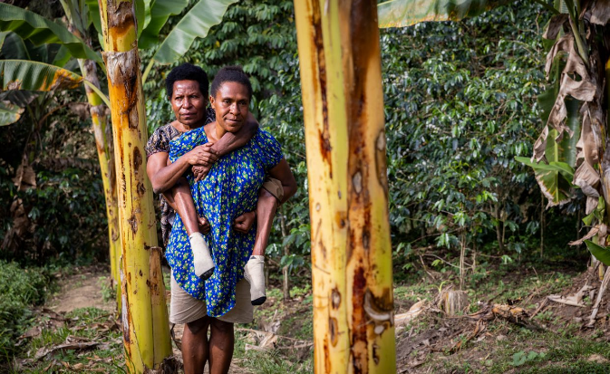

Vicky travels around her community with the assistance of her support network in Goroka, PNG. Support networks and services are always essential, however more heavily relied upon in contexts where there are limitations around accessibility and assistive technology. Photography by Erin Johnson for [Room3.com.au](http://room3.com.au/)

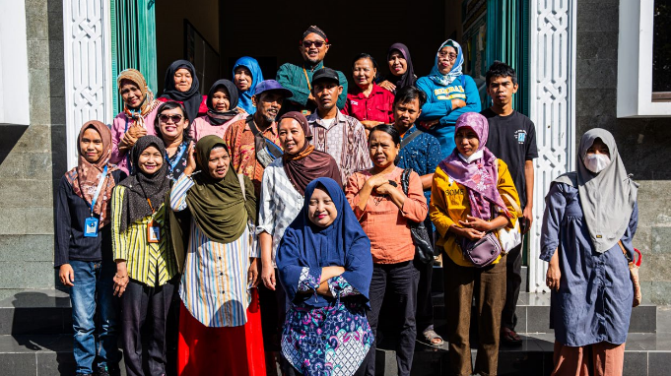

A peer-led self-help group of people with psychosocial disabilities in Indonesia. Photography by CBM Australia.

## Through precondition efforts

### Dedicated precondition efforts – from the start

Stakeholders may bring an increased focus to the preconditions by choosing to make **dedicated investments or efforts under the precondition elements.** This may particularly take place when **opportunities for new program, policy, initiatives or investments arise or are being considered.** It is also likely to occur if the stakeholder has **applied a precondition framework to analysis that will inform the decision making** about policy or programming design or direction. The scope for dedicated precondition efforts is extremely broad, and can relate to programming, policy, advisory, or service delivery – so long as these **aim to systemically address a structural gap in a precondition element across national, sub-national or community-wide contexts.**

Case study: Possible dedicated precondition activities to address gender equality for women with disabilities

A donor in a Pacific Island Country is entering a **new phase of its gender equality investment**. It wants to increase focus on preconditions for inclusion in order to ensure equity for women with disabilities. To facilitate this, they undertake **an analysis of the needs and barriers for women and girls with disabilities, with a strong focus around the preconditions for inclusion** as well as other disability equity considerations. It is identified that the gender equality investment could pursue the following programming areas to improve rights and equity for women with disabilities:

**•** Undertaking a dedicated **review of the country’s gender policies and laws** to ensure that these align with the UNCRPD and are **adequate to protect women with disabilities from the unique and additional discrimination** they experience; and working with government to implement any recommended law/policy reforms.

**•** Establishing a culturally appropriate **community-based program to assist children with high support needs** to participate in everyday activities and community events. This would include reducing exclusionary norms and establishing more embedded services and systems for their ongoing support. This program would improve **inclusion of girls with disabilities in need of support services**, as well as taking a disability rights-based approach to addressing the **informal caring responsibilities born by women and girls.**

**•** In recognition that a **lack of available assistive technology was a prohibitive barrier** to many women with disabilities **participating in gender equality initiatives** in the context, developing a program to **increase procurement and supply of assistive devices and products.**

**•** Establishing a program aimed to **prevent institutionalisation** and **violence against women with intellectual, cognitive and psychosocial disabilities**, through **peer-to-peer support, advocacy services and policy development.**

These options were taken into further conversations around design, and the **gender law/policy review** and **community-based support services projects** were implemented within the investment. Throughout the investment, the other options were also **often raised**, in **dialogues with other partners and stakeholders** working in the GEDSI space in the country, and also in planning at later stages of the investment.

### Preconditions efforts – opportunities identified ‘as you go’

Some programs, services or organisations will have **limited scope to design or implement dedicated initiatives to strengthen the preconditions, especially from the start**. This could be due to resource constraints, having a predetermined scope or mandate that can’t be changed, lack of appetite to design dedicated activities addressing systemic change, lack of technical expertise or confidence to engage on precondition areas, or more. **The preconditions are still highly relevant** in such contexts, however, and **can be brought in as activities within the program.**

This is because even where **dedicated precondition efforts are not incorporated at the start** of an individual program, service or policy processes’ design, **opportunities will still often arise ‘as you go’ within these to undertake systemic precondition efforts.** Moreover, doing so will generally **significantly strengthen the program around disability equity overall.**

Case study: Opportunity for systemic accessibility effort identified in WASH program

A WASH project in South Asia is being implemented with the objective **to provide accessible household toilets.**

The country has **no national accessible building standards**, so the project team **develop accessible toilet designs based on international guidance**. This helped ensure people with disabilities being reached by the project would be provided with inclusive WASH.

In the course of doing so, the project team **identify there is a broader opportunity to address systemic change around accessibility** by working with an OPD and relevant national government ministry to **initiate a process to develop the national building code to specify accessible WASH facilities.** These activities succeeded in passing nationally legislated accessible building standards.

**These precondition activities within the project built systematic change for future accessibility** – in the long term enabling more people with disabilities to access buildings and toilets more sustainably than if the project had focused only on delivering their accessible toilets and toilet designs.

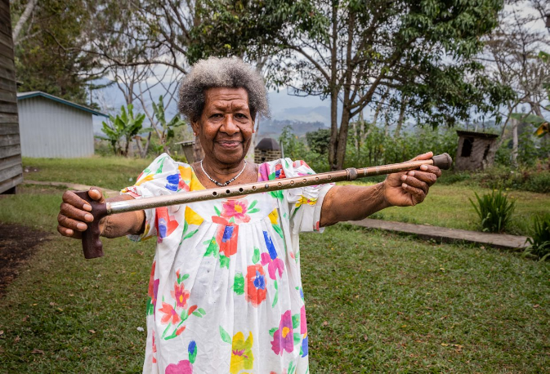

Vivian uses assistive technology and has an accessible path in her garden. Photography by Erin Johnson for [Room3.com.au](http://room3.com.au/)

Often these opportunities will be identified where there are challenges in implementing disability inclusion within general development efforts – for example, where there are **barriers and difficulties in:**

* Delivering [‘disability inclusion practices’](https://docs.google.com/document/d/10xW-52n9YRZX0znwTD5m6pYDjv6d0V76/edit#heading=h.lnxbz9)
* Reaching people with disabilities on an equitable basis as others in the community when implementing project activities.
* Ensuring evaluations and analysis adequately capture experiences and needs of people with disabilities.

This is because such difficulties may likely point to a more widespread structural gap in the broader context: that is, **the barrier to providing the disability inclusion within the general development effort may likely be a barrier that people with disabilities will be experiencing in their day-to-day lives more generally, interfering with their participation in many opportunities beyond this individual effort.** Systemically addressing this barrier or gap will therefore not only improve disability inclusion in this individual effort, but also disability equity outcomes for people with disabilities more broadly.

Opportunities to increase systemic precondition efforts within general development effort can therefore often be recognised by **identifying where there are difficulties in delivering disability inclusion** and exploring whether such difficulties are due to **an underlying structural gap in a precondition area that can be addressed through some systemic precondition activities.**

The following questions can be used to guide this process.

Guiding questions to identify opportunities for precondition activities

* **Question 1:** Is there a **difficulty in delivering disability inclusion**?
* **Question 2:** Does this difficulty indicate there is a **structural gap** around the related **precondition element**?
* **Question 3**: If so, what does this structural gap mean for people with disabilities in this context, in terms of **participating in other programs, services, opportunities and everyday life**?
* **Question 4:** Can efforts be undertaken to **more systemically address this gap**, to enable more sustainable inclusion of people with disabilities?

Practical guidance: How to identify opportunities for preconditions within other efforts ‘as you go’

|  |  |
| --- | --- |
| Example | Scenarios |
| **A** | A health program identifies that it needs to undertake **significant efforts to make hospital buildings more accessible.** |
| **B** | A governance investment finds that **when their staff with disabilities required reasonable accommodations (RAs) in the workplace** (such as adjusted workstations and vehicles or screen readers) there were often **no assistive technology technicians or related therapists available,** or the wait list was incredibly long. |
| **C** | A **gender-based violence program undertakes a mid-term evaluation.** This found a **significantly lower participation rate for women with disabilities,** even though the program design analysis identified they were one of the groups **most at risk of violence – particularly those with psychosocial, intellectual and cognitive disabilities.** The evaluation team **attempted to engage with such women** as part of the evaluation consultations, however, **were unable to facilitate this** within the visit. |

**Question 1:** Is there a difficulty in delivering disability inclusion?

|  |  |
| --- | --- |
| Example | Answer |
| **A** | Yes |
| **B** | Yes |
| **C** | Yes |

**Question 2:** Does this difficulty indicate there is a structural gap around the related precondition element?

|  |  |
| --- | --- |
| Example | Answer |
| **A** | Likely, as there are **no policies around hospital and health service building accessibility,** and **no allocated budget from the Department of Health** to address accessibility in health services. |
| **B** | Likely, as it indicates that the **sub-national context has extreme shortage** in assistive services. |
| **C** | Likely, as it **indicates that women with psychosocial, intellectual and cognitive disabilities have limited engagement with the gender-based violence program,** despite being amongst those at highest risk of violence and abuse. |

**Question 3:** If so, what does this structural gap mean for people with disabilities in this context, in terms of participating in other programs, services, opportunities and everyday life?

|  |  |
| --- | --- |
| Example | Answer |
| **A** | Lack of policies around hospital and health service building accessibility, and lack of government budget for this, will have **impact on people with disabilities’ access to health in districts beyond the scope and timeframe of this investment.** |
| **B** | **Lack of available technicians and therapists** to assess, fit and maintain assistive products and devices, **will dramatically impact people with disabilities’ participation in all facets of live.** |
| **C** | Discussions with women with disabilities in the evaluation indicated that they observed women with psychosocial and intellectual disabilities often **found it difficult to engage with services generally,** due to: **lack of support services** to facilitate participation; **very high discriminatory norms in community and from service providers** about their disability type; and **discriminatory laws and practices that meant some are at times subject to involuntary hospitalisation** rather than community-based support and treatment. Literature from peak psychosocial and intellectual disability OPDs supports this messaging. |

**Question 4:** Can efforts be undertaken to more systemically address this gap, to enable more sustainable inclusion of people with disabilities?

|  |  |
| --- | --- |
| Example | Answer |
| **A** | Yes, we can **introduce activities to engage with the Department of Health** to explain why a policy and budget for accessibility of hospitals and health services is important and support them to develop these. |
| **B** | Yes, we can **introduce assistive services into the workforce development activities** our investment undertakes. |
| **C** | Yes, our program has a strong outcome area around **empowerment and rights awareness raising** for women and **working with the community to challenge harmful norms and practices** that contribute to violence. An area of these kind of activities that particularly focus on the rights of women with psychosocial, intellectual and cognitive disabilities can be introduced to target exclusion due to discrimination. This would need to be done **in partnership with the disability movement.** |

# Additional approaches and resources

Most organisations’ approaches of the preconditions for inclusion cover additional elements beyond the four core elements listed above, as relevant to their unique context and purpose. **These versions should not be seen to conflict or compete with each other.** All frameworks are aligned in the preconditions’ primary aim and objectives, i.e. to ensure the structural enabling environment required for equal participation, and there is substantial overlap between all the approaches which makes them mutually reinforcing. The differences come because the organisations having **differing points of focus** (e.g. UNPRPD taking a strong focus on budgeting and accountability systems), **and context** (e.g. PDF taking a strong focus on CBID because this is a particular priority for their members and in the Pacific). As such, each approach reflects preconditions for inclusion **as relates to the organisation’s main scope of influence, and systemic and structural gaps most persistent in the main contexts in which they operate.** Together, these slightly varying approaches – and all stakeholders involved in their uptake and implementation - have the potential to complement each other to achieve transformative change regionally and globally for the rights of people with disabilities.

## CBM Global’s approach to preconditions

CBM Global’s approach to the preconditions outlines the above four key common element as the preconditions for inclusion, as well as ‘four further foundational elements’ seen as essential to implementing an enabling environment for disability equity and rights. These are set out below.

Recognising the extra costs of disability

People with disabilities and their families face additional direct costs, such as those related to mobility aids, sign language interpreting and healthcare, and indirect costs, such as lost income due to systemic discrimination or caregiving responsibilities. These extra costs are often a pervasive barrier that prevent people with disabilities and their families from being able to participate in opportunities and everyday life on an equal basis. Policies and programs must systemically address these costs, including through disability inclusive social protection for people with disabilities and their carers, and inclusive livelihoods and training.

Community inclusion

Ensuring that people with disabilities can participate in everyday life requires not only empowering them and addressing support needs but also facilitating communities to be more inclusive and strong agents of change for disability inclusion. This involves building inclusive support networks, mobilising communities, peer support, strengthening outreach and referral pathways, and engaging with existing groups like faith, sports, and women’s organisations. Community Based Inclusive Development (CBID) is a key approach to achieving community-level inclusion.

Participation and empowerment

People with disabilities and their representative organisations (OPDs) have the right to actively participate in decisions affecting them (Articles 4 and 32, UNCRPD).

Facilitating this through a rights-based approach involves efforts such as: appropriately resourcing OPDs; ensuring that processes meaningfully involve OPDs that represent all people with disabilities, including those from underrepresented and marginalised groups; collaborating with the disability movement to ensure their priorities are heard; and supporting and building capacity of people with disabilities and OPDs.

Data and inclusive budgeting

Reliable data is essential for planning, implementing, and monitoring disability-inclusive policies and programs. Data on barriers and the participation of people with disabilities helps inform decision making. Inclusive budgeting is equally important to ensure adequate resources are allocated to support disability-inclusive policies.

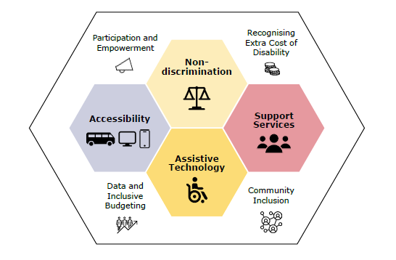

CBM Global’s approach to the preconditions

## Pacific Disability Forum’s approach to preconditions

PDF’s approach to the preconditions includes six elements: assistive technology, non-discrimination, accessibility, support services, social protection, and community-based inclusive development.

Social Protection

PDF includes social protection as a precondition in recognition that the additional direct and indirect costs of disability are often prohibitive to equal participation for people with disabilities and their families. Strong systemic social protection mechanisms that include people with disabilities within mainstream schemes, as well as provide for specific disability benefits, are essential to addressing this structural gap. Social protection should consider the caring roles of families with disabilities, particularly within cultural contexts, as well as protecting the right of people with disabilities to work alongside receiving benefits to address their disability costs.

Community-based inclusive development (CBID)

PDF also includes CBID as a precondition, in recognition of how this addresses structural gaps to connect people with disabilities and the services, programs and supports they require. CBID is described by PDF as the ‘last mile’ of service delivery. CBID strengthens local systems and supports communities to address barriers as needed in local context using community resources. It includes community mobilisation, community strengthening, and community health workers or field workers who undertaking activities such as outreach, identification, referral, support and in-home services.

As well as facilitating access to disability specific services and supports, CBID also has a strong element of strengthening access to and inclusion in the general community services and opportunities. This means CBID has strong linkages across different sectors.

CBID is particularly important in contexts where there are additional factors for exclusion. For example, in remote settings, for people experiencing high marginalisation due to particularly high discrimination around having a disability or their specific disability type, or for people with high support needs.

PDF Precondition Issues Papers

PDF prepared the [Preconditions for Inclusion Issues Paper Series](https://pacificdisability.org/resources/) to assist the sector’s understanding of: what PDF’s preconditions for inclusion framework is and why it is important; what is involved under each of precondition areas within the Pacific context; the current progress regarding each of the precondition areas in the Pacific; and key issues in the Pacific under each of the precondition areas, for stakeholders to consider if we are to achieve full rights and equity for persons with disabilities in our region.

## Further resources and other organisations’ approaches

* **OHCHR (2024)** [Foundations: Key concepts and structural requirements to create an enabling legal, policy and programming environment](https://www.ohchr.org/sites/default/files/documents/issues/disability/sdg-crpd-resource/policy-guidelines/foundations-noimages-v2.pdf). Part of a broader SDG-CRPD resource package, this first ‘Foundational’ guidance note focuses on the ‘overarching principles’ required to support SDG-CRPD implementation: non-discrimination, accessibility, assistive technology, support services, participation and awareness raising.
* **UNPRPD (undated)** [The preconditions necessary to ensure disability inclusion](https://unprpd.org/archived/sites/default/files/library/2020-08/Annex%202%20UNPRPD%204th%20Funding%20Call%20Preconditions%20to%20disability%20inclusion%20ACC.pdf): This outlines how the UNPRPD applies its Preconditions for Inclusion framework to its policies, systems and services.
* **Special Rapporteur on the Rights of Persons with Disabilities (2016)** - [Report on Disability-Inclusive Policies](https://www.ohchr.org/en/documents/thematic-reports/a71314-report-disability-inclusive-policies). This report provides guidance on how to ensure policies and strategic frameworks are fully inclusive of people with disabilities. It highlights that accessibility, assistive technology, support services and non-discrimination are ‘pre-requisites’ for achieving the SDGs and the CRPD.

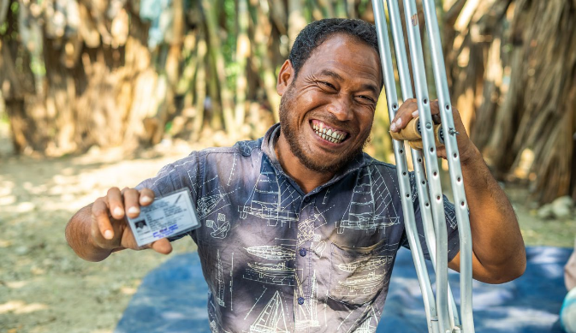

Disability identification cards (“Suborno Nagorik Cards”) facilitating access to social protection and assistive technology are both essential to enabling equal participation in Cox’s Bazaar. Image credit: CBM



**CBM IAG** is a global network of advisors, working in partnership with the Disability Movement on catalytic opportunities that have potential to spark broader, systemic change for inclusion. IAG is an initiative of CBM Global Disability Inclusion and our advisory support to external partners is a key element of CBM Global’s efforts towards greater inclusion, alongside our field programmes and advocacy work.

IAG acknowledges the Traditional Owners of the lands on which we live, learn and work and pay our respects to their Elders, past and present. Throughout our work, we acknowledge First Nations peoples’ resilience, contributions and connection to Country and culture, and stand with First Nations’ people and their movements.

IAG is grateful for the invaluable contributions that the disability movement, particularly the PDF and Transforming Communities for Inclusion (TCI) Global, have made to IAG’s understanding and conceptualisation of the preconditions for inclusion. It is an honour and privilege to work with the international disability movement.

**Contact**

**CBM IAG** PO Box 196, Richmond VIC 3121, Australia

[cbm@cbm.org.au](mailto:cbm@cbm.org.au)

[www.inclusionadvisorygroup.org](http://www.inclusionadvisorygroup.org)



**Pacific Disability Forum** is a constituency of 71 organisations of & for persons with disabilities and associate members representing diverse groups of persons with disabilities and their supporters, across in 22 Pacific Island countries and territories.

PDF’s work includes supporting member OPDs through funding for disability activities and grass-roots programs, capacity development, mentoring, training and other support; as well as advocacy, policy advice, representation and more to Pacific Island Governments, donors, multilateral organisations, civil society, contractors and other stakeholders across all aspects of development, humanitarian, rights and policy, at the national, regional and international levels.

**Contact**

**Pacific Disability Forum** Ground Floor, Kadavu House, Victoria Parade, Suva, Fiji Islands GPO Box 18458, Suva, Fiji Islands

(+679) 773 0200 or (+679) 331 2008

www.pacificdisability.org

1. The core common elements of the preconditions are used in this diagram for simplicity however the

   interdependence and interlinkages also extend to further elements often applied by organisations.