Plain language summary – the Treaty on the Protection of Persons in the Event of Disasters (PPED)


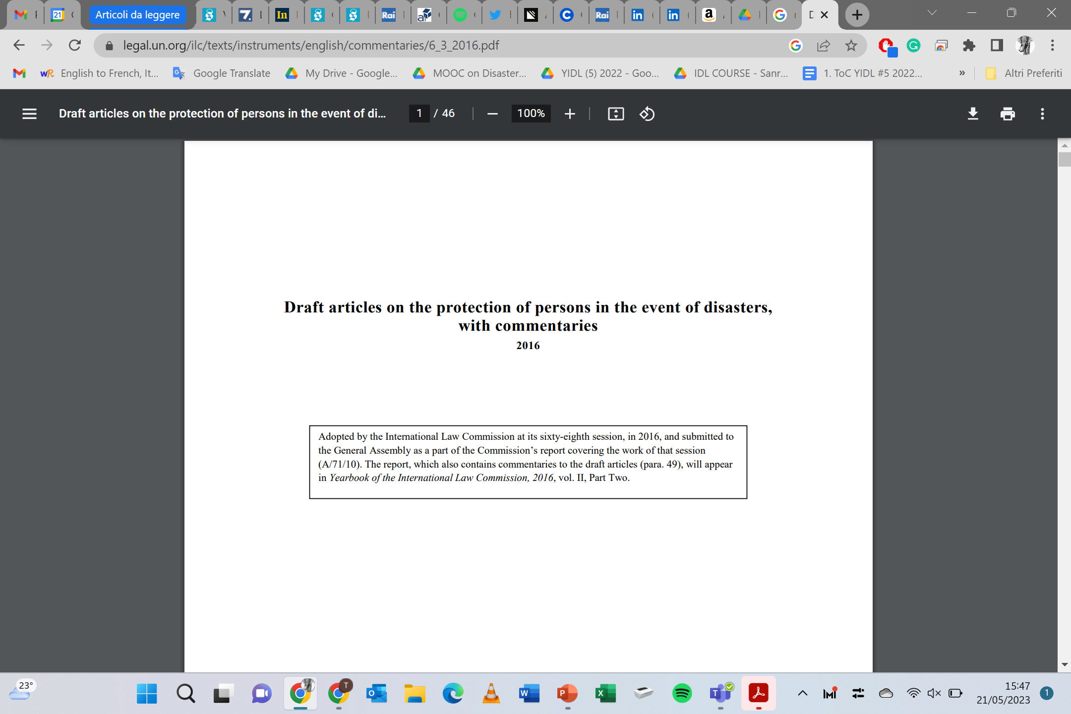
The International Law Commission (ILC) is a group of international law experts appointed by the UN General Assembly to study legal issues and recommend new rules.
The ILC developed a set of 18 Draft Articles on the Protection of Persons in the Event of Disasters.
These Draft Articles are not yet legally binding, but they provide a framework for how countries should cooperate during disasters.

How the Draft Articles were developed
- Work began in 2008 and the articles were completed in 2016.
- In 2016, the ILC sent the Draft Articles to the UN General Assembly and recommended turning them into a treaty.
- Over the next 8 years, UN Member States discussed them.
- In December 2024, the UN General Assembly agreed to develop a legally binding treaty based on the Draft Articles by the end of 2027.

Amendments and consolidated text
- Countries were invited to submit proposed changes by 31 December 2025. These are now published on the UN website.
- A consolidated text (bringing all proposals together) is expected by March 2026.

Next steps in 2026–2027
1. Sixth Committee Meeting (6–10 April 2026)
- Member States will continue technical discussions on the consolidated text.
- This is a key moment to refine the document before it goes to the Preparatory Committee.
2. Preparatory Committee Meeting (31 August – 4 September 2026)
The committee will:
- Send the consolidated text and government proposals to the Conference of Plenipotentiaries.
- Decide how non-State stakeholders (observers, NGOs, etc.) can participate.
- Recommend rules and working methods for the Conference.
3. United Nations Conference of Plenipotentiaries on the PPED (25 January – 12 February 2027)
- This conference will be held in Manila, hosted by the Philippines.
- Purpose: negotiate and finalise the new Disaster Law Treaty.
- If needed, the conference may reconvene for two more weeks in August 2027.
- The final treaty must be concluded before the end of 2027.

